Investigating the effect of initial speed on stopping distance
Introduction
In this experiment you will investigate the effect of speed on stopping distance and try to determine the relationship between the two variables.
You will also research other published data to compare with the outcome of your experiment.
Aim
- To graph the relationship between speed and stopping distance
- To identify the characteristic of that relationship
- To compare your results with published data
Intended class time
- 60 to 90 minutes
Equipment (per group)
- wooden block
- interrupt card
- data logging system
- light gate
- metre rules x2
Health and safety
Beware of falling objects.
Procedure
- The wooden block represents a car, which if pushed and then left to travel freely will travel for a distance before coming to rest.
- The cardboard interrupt card, which should be pinned to the side of the wooden block, allows the light gate to determine the initial speed of the car.
- Before starting the experiment it is a good idea to practise pushing the car to be able to achieve both short and longer stopping distances, without going beyond the edge of the bench.
- It is not practical to take repeat readings in this experiment, so you will need another strategy to improve the accuracy of your graph.
- It can also be a good idea to establish the extremes of your data to be able to define the axes for your graph and to plot the results as they are obtained.

- Push the block, ensuring that you have released it before it passes through the light gate. Record the speed, from the data logger, and the stopping distance.
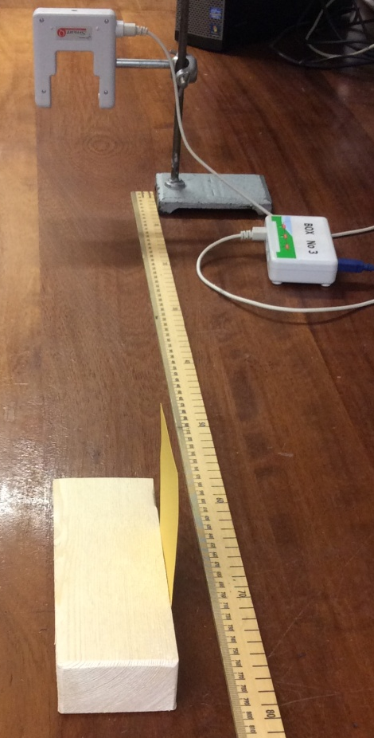
- Repeat the experiment to obtain sufficient data to plot a graph of the relationship between speed and stopping distance.
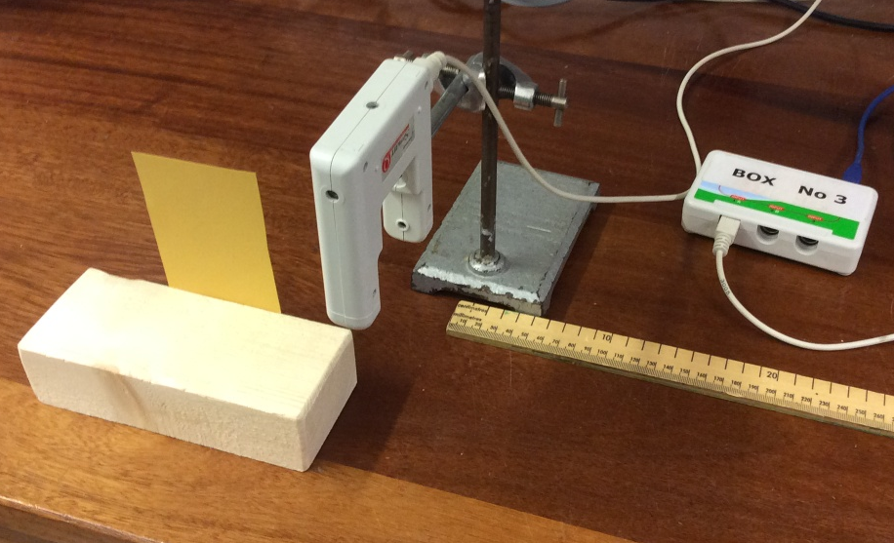

Analysing the data
- Describe the shape of your graph
- Using your graph, if speed is doubled, by what factor does the stopping distance increase?
- Is this increase consistent across the full range of the graph?
- Predict what will happen to stopping distance if speed is tripled.
- Test your prediction using your graph.
Explaining the outcome
Explain this outcome from physics you have learned.
Validating the relationship
The relationship between speed and stopping distance is very important for drivers and road safety. Research another source of data on stopping distances of cars and compare their data with that of your experiment. In your records make an appropriate reference to the source of the material.

Extension
- How did you overcome the inability to take repeat readings?

- What is the advantage of plotting points as you carry out the experiment?

- What graph could you draw to validate if your proposed relationship is valid?
Recording
As evidence for the Practical Endorsement you should have the data collected from your group in a clear and logical format. You should have compared your result with an accepted source and referenced the source appropriately. All work should be clearly dated.

In addition, in preparation for the assessment of practical work in the written examination and to help you develop your understanding, you should have used the data collected to plot a graph of speed against stopping distance and answered the extension questions.

