BWS A’ Level Physics
Year 12 Independent Study Forces and Motion Booklet D
Write all your answers in the spaces provided and use additional sheets where necessary.
This booklet is available for download on the website but may be updated so check you have an up to date copy.
A C by a certain activity indicates this is compulsory and must be completed ready for the next week as your lessons may depend on your ability to follow certain techniques or content.
Finally this booklet must be available for inspection at all times in your file.
Grade boundaries throughout for consolidation work are:
- A 80%
- B 70%
- C 60%
- D 50%
- E 40%
- U <40%

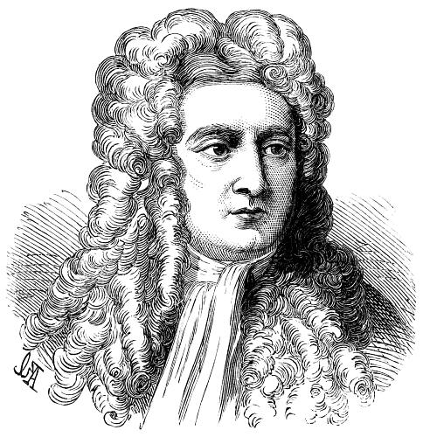

Week | Topic | Prep / Consolidation | Practice |  |  | Target Areas for improvement
Week | Topic | Prep / Consolidation | Complete | Practice Mark and Grade | Corrected | Target Areas for improvement
21 | Newton’s Laws |  |  | / 23 Grade:
22 | Momentum and Newton’s Laws |  |  | / 31 Grade:
23 | Conservation of momentum in collisions |  |  | / 15 Grade:
 | Topic Test D |  |  | / Grade:

21. Newton’s Laws
Independent Study tasks this week:
Notes: | Completed
Make revision notes/cards on Work Done and Kinetic Energy
Independent Study Learning Preparation task:  Print out the following sheet and complete the definitions using your text book 100-108 to help you. Include any appropriate equations and learn the definitions precisely. Q:\Physics\Year 12 Mechanics\23. Newton's laws and momentum\Y12 Newtons Laws definitions.docx | C
Isaac Physics
Complete questions F1
Independent Study Practice Questions:  complete all the questions in the spaces provided | C

- State Newton’s first law of motion.

- State Newton’s second law of motion

- Show that F =ma is a special case of Newton’s second law if the mass is constant.

4. A golf ball of mass 200 g is hit by a club and acquires a velocity of 60 ms-1 in a time of 5.0 ms. Calculate:
a) The change in momentum.

b) The net force acting.

5. A cricket ball of mass 250g is bowled towards the batsman at 20 ms-1 and returned at 35 ms-1 in the opposite direction. The ball is in contact with the bat over a distance of 0.60m.
a) Define impulse.

b) Use the momentum change of the ball to find the impulse.

c) Calculate the time for which the bat and ball are in contact.

d) Use the answers above to find the magnitude of the force acting on the ball.

6. State Newton’s third law of motion.

7. Two cars, A and B are involved in a low speed shunt. Car A of mass 1500 kg drives into the back of car B at 6 ms-1. Car A stops in a distance of 1.50m. Minor damage happens to both cars. Car B has a mass of 1250 kg and is initially at rest.
a) Calculate the initial momentum of car A.

b) Use SUVAT to find the deceleration of car A.

c) Calculate the force acting on car A.

TAP 211-2 Newton’s second law

Simple calculations and a little thinking.
An 80 kg skier has a force of 200 N exerted on him down the slope.
1. Calculate his acceleration down the slope.

2. Is the slope less than or more than 45o? Explain your answer.

An ice hockey player has a sudden impact force of 2000 N exerted on him due to unexpected collision with the wall. The mass of the player is 100 kg.
3. Find his acceleration.

4. Compare this with the acceleration when he free falls.

Coming out of a dive, 75 kg astronauts in training experience an acceleration of 40 m s–2.
5. Calculate the force acting on them.

6. Compare this with the force which normally acts on them when stationary on Earth.

7. Why is it important that they are seated and strapped in before the dive ends?

A 50 g tennis ball may be accelerated at 1000 m s–2 to reach a service speed of 130 mph.
8. Calculate the force required to accelerate the ball.

9. Is your answer reasonable? Comment.
………………………………………………………………………………………………………………………
………………………………………………………………………………………………………………………
………………………………………………………………………………………………………………………
………………………………………………………………………………………………………………………
………………………………………………………………………………………………………………………

When a force of 200 N is exerted on an asteroid it accelerates at 0.002 m s–2.
10. Find the mass of the asteroid.

22. Momentum and Newton’s Laws
Independent Study tasks this week:
Notes: | Completed
Make revision notes/cards on Conservation of momentum, elastic and inelastic collisions
Independent Study Learning Extension task:
Answer questions in the sheet Work & E_{k} and be prepared to explain your answer to others in the class. Q:\Physics\Year 12 Mechanics\13. Work Done\Work done and Kinetic Energy.docx
Isaac Physics  Complete ‘questions F2 – conservation of momentum | C
Independent Study Practice Questions:  complete all the questions in the spaces provided | C
1 (a) State Newton’s second and third laws of motion.


In your answer, you should use appropriate technical terms spelled correctly.

(i) second law

...........................................................................................................................................

...........................................................................................................................................

.................................................................................................................................... [1]

(ii) third law

...........................................................................................................................................

...........................................................................................................................................

.................................................................................................................................... [1]

(b) A golfer uses a golf club to hit a stationary golf ball off the ground. Fig. 1.1 shows how the force F on the golf ball varies with time t when the club is in contact with the ball. The club is in contact with the ball for 1.2 ms in total.

3500

3000

2500
Force /N

2000

1500

1000

500

0
0 0.2 0.4 0.6 0.8 1.0 1.2 1.4

t/ms

(i) Estimate the area under the graph.

area = ................................................... N s [2]

(ii) Name the physical quantity represented by the area under the graph in (i).


In your answer, you should use appropriate technical terms spelled correctly.

.................................................................................................................................... [1]

(iii) Show that the speed of a golf ball, of mass 0.046 kg, as it leaves the golf club is about 50 m s–1.

speed = ............................................... m s–1 [2]

(iv) The ground is level. The ball leaves the ground at a velocity of 50 m s–1 at an angle of 42° to the horizontal. Determine the horizontal distance travelled by the ball before it hits the ground.

State one assumption that you make in your calculations.

distance = ........................................................... m

assumption ........................................................................................................................

.................................................................................................................................... [5]
2 (a) (i) State the principle of conservation of linear momentum.

...........................................................................................................................................

...........................................................................................................................................

.................................................................................................................................... [2]

(ii) Explain what is meant by an inelastic collision.

...........................................................................................................................................

.................................................................................................................................... [1]




(iii) The diagram below shows the head-on-collision of two blocks on a frictionless surface.
 |  | 3.0 | ms-1 2.0 | ms-1 |  |  |  |  |  | v

BEFORE COLLISION
AFTER COLLISION

Before the collision, the 2.4 kg block is moving to the right with a speed of 3.0 m s–1 and the 1.2 kg block is moving to the left at a speed of 2.0 m s–1. During the collision the blocks stick together. Immediately after the collision the blocks have a common speed v.

1 Calculate the speed v.

v = ...........................................ms⁻¹ [2]

2 Show that this collision is inelastic.

[2]

(b) Fig. 2 shows a helicopter viewed from above.

rotating blade

5.0m

Fig. 2

The blades of the helicopter rotate in a circle of radius 5.0 m.When the helicopter is hovering, the blades propel air vertically downwards with a constant speed of 12 m s–1. Assume that the descending air occupies a uniform cylinder of radius 5.0 m.

The density of air is 1.3 kg m–3.

(i) Show that the mass of air propelled downwards in a time of 5.0 seconds is about 6000 kg.

[2]
(i) Calculate

1 the momentum of this mass of descending air

momentum = ........................................... kg m s–1 [1]

2 the force provided by the rotating helicopter blades to propel this air downwards

force = ..................................................... N [2]

3 the mass of the hovering helicopter.

mass = .................................................... kg [1]

3. In a low speed car crash, a car of mass 1300 kg collides into the back of a stationary van, mass 2500 kg at 10 ms-1. After the impact the cars move coalesced.
a) Calculate the total momentum before the impact.

b) Calculate the final velocity with which the two vehicles move off at.

c) State what is meant by an inelastic collision.

d) Show that this collision is inelastic.

23. Conservation of momentum in collisions
Independent Study tasks this week:
Notes: | Completed
Make revision notes/card Newton’s laws, momentum, elastic and inelastic collisions and revise for a test. | C
Independent Study Consolidation task:  Complete past paper questions to help revise for the end of topic test. Q:\Physics\Year 12 Mechanics\Revision resources\4 Mechanics momentum impulse and collisions resources\Revision questions for Momentum Impulse and collisions.docx | C
Isaac Physics
Complete previous set tasks not yet completed.
Independent Study Practice Questions:  Complete these questions below | C

Collisions in Two Dimensions.
- A gas molecule of mass m collides perfectly elastically with a smooth surface. It is initially travelling at a speed U at an angle θ to the normal and rebounds at the same angle as shown in the diagram below at the same speed U.
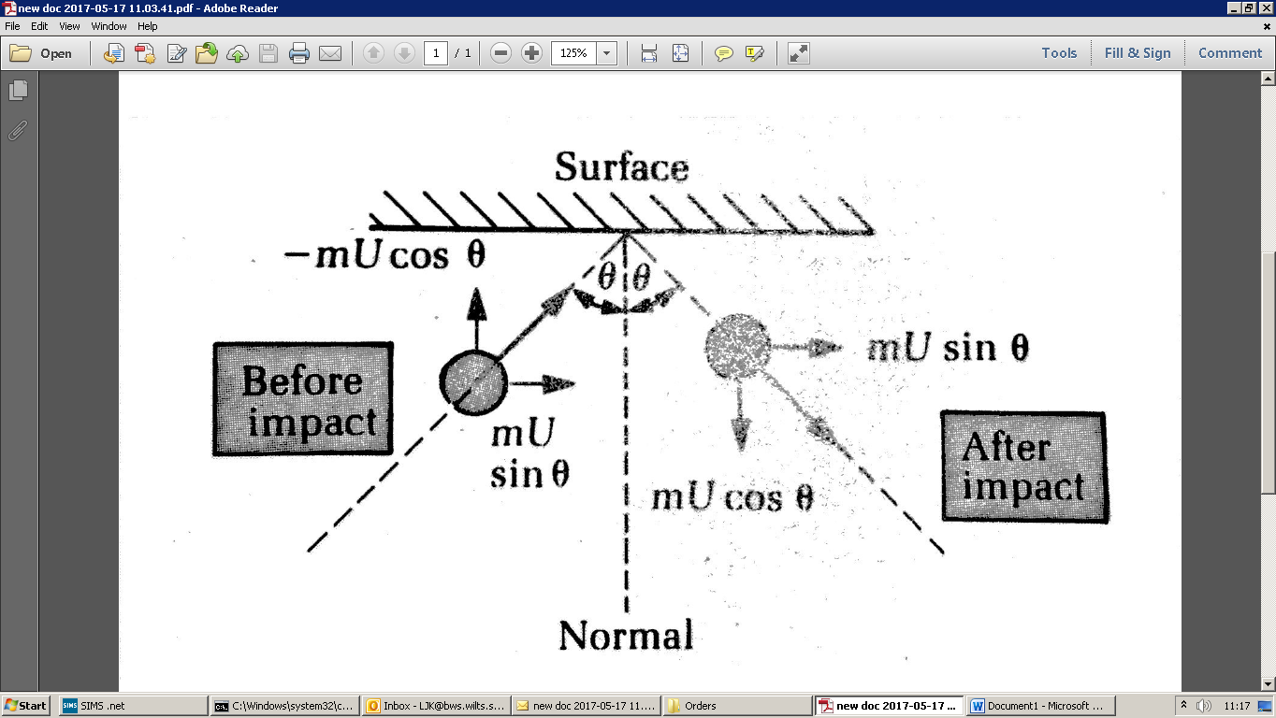
Write expressions for the vertical and horizontal components of the momentum before impact.
Vertical =
Horizontal =

Write expressions for the vertical and horizontal components of the momentum after impact.
Vertical =
Horizontal =
Show that the change in momentum of the molecule is 2mUcosθ.

- Sphere A of mass m and velocity v is incident on a stationary sphere B of equal mass m. The collision is elastic and after the collision A moves with a velocity v₁ at an angle of 60º to its original direction and B moves with a velocity v₂ at an angle θ to the direction of v.
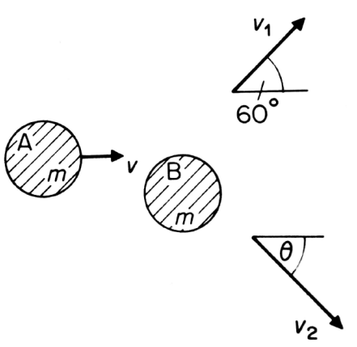
- Draw a vector diagram to represent the conservation of momentum in the collision.

- Either by scale drawing or otherwise, state and explain angle θ.

- Derive expressions (in terms of the original speed v) for v₁ and v_{2.}

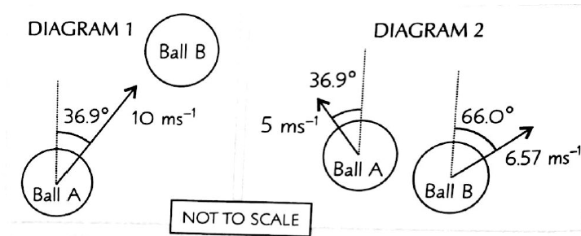
- Ball A collides with stationary ball B, as shown in diagram 1. After the collision, the two balls move off as shown in diagram 2. Ball A has a mass of 40g. Calculate the mass, m, of ball B.

