BWS A’ Level Physics
Year 12 Independent Study Forces and Motion Booklet C
Write all your answers in the spaces provided and use additional sheets where necessary.
This booklet is available for download on the website but may be updated so check you have an up to date copy.
A C by a certain activity indicates this is compulsory and must be completed ready for the next week as your lessons may depend on your ability to follow certain techniques or content.
Finally this booklet must be available for inspection at all times in your file.
Grade boundaries throughout for consolidation work are:
- A 80%
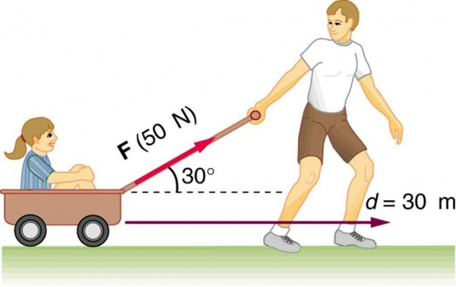
- B 70%
- C 60%
- D 50%
- E 40%
- U <40%

Week | Topic | Prep / Consolidation | Practice |  |  | Target Areas for improvement
Week | Topic | Prep / Consolidation | Complete | Practice Mark and Grade | Corrected | Target Areas for improvement
14 | Work Done and Kinetic Energy |  |  | / 43 Grade:
15 | Work Done and Power |  |  | / 42 Grade:
16 | Car safety and the highway code |  |  | / 24 Grade:
17 | Hooke’s Law |  |  | / 23 Grade:
18 | Springs in Series and Parallel PAG |  |  | / 25 Grade:
19 | Young Modulus |  |  | / 33 Grade:
20 | Breaking stress and Progress test C |  |  | / Grade:

14. Work Done and Kinetic Energy
Independent Study tasks this week:
Notes: | Completed
Make revision notes/cards on Work Done and Kinetic Energy
Independent Study Learning Preparation task:  Using powerpoint presentation follow all instructions to create detailed notes on the different forms of energy and Sankey diagrams. Q:\Physics\Year 12 Mechanics\14. Conservation of energy\Conservation of Energy Preparation.pptx | C
Isaac Physics
Read concept pages on Work and conservation of momentum (only up to level 3 at the moment)
Independent Study Practice Questions:  complete all the questions in the spaces provided | C
1 (a) Define work done by a force.
……………………………………………………………………………………………………………
……………………………………………………………………………………………………………
[1]
(b) A broken down car is pushed with a force of 500 N against a constant resistive force of 380 N for a distance of 10m.
Calculate:
(i) The work done by the pushing force.

……………………………………….J
[2]
(ii) The work done against the resisting force.

…………………………………………J
[1]

(iii) The kinetic energy gained.

……………………………………………J
[1]
(iv) Given that the mass of the car is 1700 kg, calculate the speed obtained after it has been pushed 10 m.

……………………………………..ms⁻¹
[2]
2 (a) Define the joule.
………………………………………………………………………………………………………………………………………………………………………………………………………………………………………………………………………………………………………………………………………………………………………………………………………………………………………………………………………………………
[1]
(b) When a force F moves an object of mass m through a distance of s work is done and the object gains kinetic energy. Show that the kinetic energy gained is ½ mv².

[3]
(c) A car of mass 1800 kg is travelling at a speed of 110 kmh⁻¹ when the driver applies the brakes. The car comes to rest in a braking distance of 45.0 m.

(i) Calculate the initial kinetic energy of the car.

……………………………
[3]
(ii) Calculate the braking force.

…………………………………………
[3]
(d) A van of mass 2700 kg is also travelling at 110 kmh⁻¹. Its brakes are capable of providing the same force as the car’s brakes. Without further calculation, state the braking distance of the van. Justify your answer.
Distance:………………………………………………………………………………………………

Justification:……………………………………………………………………………………………
………………………………………………………………………………………………………….
[3]
3. A crane is used to lift a mass of 2000 kg through a vertical height of 15 m.
a) Calculate the work done by the force.

[2]
b) If the efficiency of the crane’s motor is 33%, calculate the total energy input.

[3]

4. A skydiver of mass 70 kg, jumps from a stationary balloon and reaches a speed of 45 m s–1 after falling a distance of 150 m.
(a) Calculate the skydiver’s
(i) loss of gravitational potential energy,
...........................................................................................................................
...........................................................................................................................
(ii) gain in kinetic energy.
...........................................................................................................................
...........................................................................................................................
(4)
(b) The difference between the loss of gravitational potential energy and the gain in kinetic energy is equal to the work done against air resistance. Use this fact to calculate
(i) the work done against air resistance,
...........................................................................................................................
...........................................................................................................................
(ii) the average force due to air resistance acting on the skydiver.
...........................................................................................................................
...........................................................................................................................
...........................................................................................................................
(3)
(Total 7 marks)
5. (a) Explain why a raindrop falling vertically through still air reaches a constant velocity. You may be awarded marks for the quality of written communication in your answer.
.....................................................................................................................................
.....................................................................................................................................
.....................................................................................................................................
.....................................................................................................................................
.....................................................................................................................................
.....................................................................................................................................
.....................................................................................................................................
.....................................................................................................................................
(4)

(b) A raindrop falls at a constant vertical velocity of 1.8 m s^{–1} in still air. The mass of the raindrop is 7.2 × 10–9 kg.
Calculate
(i) the kinetic energy of the raindrop,
...........................................................................................................................
...........................................................................................................................

(ii) the work done on the raindrop as it falls through a vertical distance of 4.5 m.
...........................................................................................................................
...........................................................................................................................
(4)
(c) The raindrop in part (b) now falls through air in which a horizontal wind is blowing. If the velocity of the wind is 1.4 m s^{–1}, use a scale diagram or calculation to determine the magnitude and direction of the resultant velocity of the raindrop.

.....................................................................................................................................
.....................................................................................................................................
.....................................................................................................................................
(3)
(Total 11 marks)

15. Work done and Power
Independent Study tasks this week:
Notes: | Completed
Make revision notes/cards on Work done and Power
Independent Study Learning Extension task:
Answer questions in the sheet Work & E_{k} and be prepared to explain your answer to others in the class. Q:\Physics\Year 12 Mechanics\13. Work Done\Work done and Kinetic Energy.docx
Isaac Physics  Complete ‘Work Energy and Power’ gameboard | C
Independent Study Practice Questions:  complete all the questions in the spaces provided | C
1 (a) Define work done by a force.

...................................................................................................................................................

.............................................................................................................................................. [1]

- Define power.

...................................................................................................................................................

.............................................................................................................................................. [1]

(c) Define the watt

...................................................................................................................................................

.............................................................................................................................................. [1]

(d) Explain why the efficiency of a mechanical device can never be 100%.

...................................................................................................................................................

.............................................................................................................................................. [1]

(e) A car has a total mass of 810 kg. Its speed changes from zero to 30 m s^{–1} in a time of 12 s.

- Calculate the change in the kinetic energy of the car.

change in kinetic energy = ....................................................... J [2]

- Calculate the average power generated by the car engine. Assume that the power generated by the engine of the car is entirely used in increasing the kinetic energy of the car.

power = ......................................................W [1]

- The actual efficiency of the car is 25%. The car takes 18 kg of petrol to fill its tank. The energy provided per kilogram of petrol is 46 MJ kg^{–1}. The drag force acting on the car at a constant speed of 30 ms^{–1} is 500 N.

1 Calculate the work done against the drag force per second.

work done per second = .................................................. J s^{–1} [1]

- Calculate the total distance the car can travel on a full tank of petrol when travelling at a constant speed of 30 m s^{–1}.

distance = ...................................................... m [3]

2 In February 1999 NASA launched its Stardust spacecraft on a mission to collect dust particles from the comet Tempel 1. After a journey of 5.0 × 10¹² m that took 6.9 years, Stardust returned to Earth with samples of the dust particles embedded in a special low-density gel. When a dust particle hits the gel, it buries itself in the gel creating a cone-shaped track as shown in Fig. 2. The length of the track is typically 200 times the diameter of the dust particle.
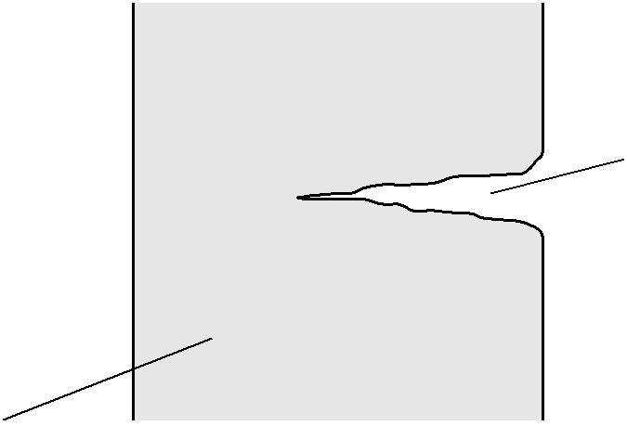

not to scale

cone-shaped track

gel

Fig. 2

(a) Calculate the average speed in m s^{–1} of Stardust during its voyage.

speed = ................................................. m s^{–1} [2]

- Calculate the average stopping force produced by the gel for a dust particle of diameter 0.70 mm and mass 4.0 × 10^{–6} kg travelling at a velocity of 6.1 × 10³ m s^{–1} relative to Stardust.

force.......................................................N [3]

3 (a) State the principle of conservation of energy.

...................................................................................................................................................

.............................................................................................................................................. [1]

(b) Describe one example where elastic potential energy is stored.

.............................................................................................................................................. [1]

(c) Fig. 5.1 shows a simple pendulum with a metal ball attached to the end of a string.
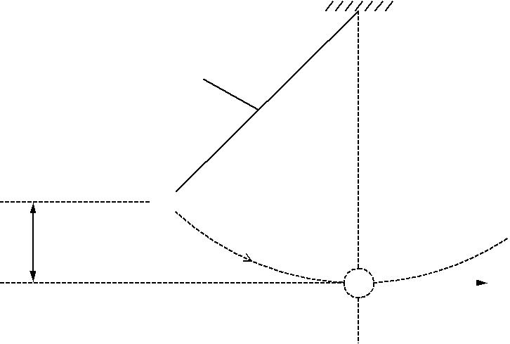

string

m
P

h

v

Fig. 5.1

When the ball is released from P, it describes a circular path. The ball has a maximum speed v at the bottom of its swing. The vertical distance between P and bottom of the swing is h. The mass of the ball is m.

- Write the equations for the change in gravitational potential energy, E_{p}, of the ball as it drops through the height h and for the kinetic energy, E_{k}, of the ball at the bottom of its swing when travelling at speed v.

E_{p} =

E_{k} = [1]

- Use the principle of conservation of energy to derive an equation for the speed v. Assume that there are no energy losses due to air resistance.

[2]

- Some countries in the world have frequent thunderstorms. A group of scientists plan to use the energy from the falling rain to generate electricity. A typical thunderstorm deposits rain to

a depth of 1.2 × 10^{–2} m over a surface area of 2.0 × 10⁷ m² during a time of 900 s. The rain falls from an average height of 2.5 × 10³ m. The density of rainwater is 1.0 × 10³ kg m^{–3}. About 30% of the gravitational potential energy of the rain can be converted into electrical energy at the ground.

(i) Show that the total mass of water deposited in 900 s is 2.4 × 10⁸ kg.

[2]

- Hence show that the average electrical power available from this thunderstorm is about
2 GW.

[3]

- Suggest one problem with this scheme of energy production.

...........................................................................................................................................

...................................................................................................................................... …..[1]

4 (a) Fig. 4.1 shows a side view of a roller coaster.

A
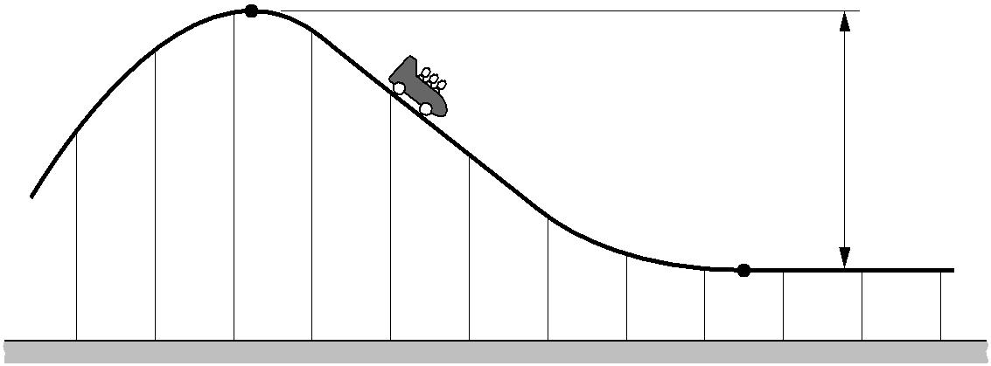

110 m

B

Fig. 4.1

The carriage and its passengers start at rest at A. At B, the bottom of the ride, the maximum speed of the carriage is 20 m s^{–1}. The vertical distance between A and B is 110 m. The length of the track between A and B is 510 m. The mass of the carriage and the passengers is 4000 kg.

- Complete the sentence below.
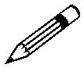
In your answer, you should use appropriate technical terms, spelled correctly.

As the carriage travels from A to B, …………………………………….........…… energy

is transferred to ………………………………………… energy and heat. [2]

- By considering this energy transfer from A to B, determine the average frictional force acting on the carriage and passengers between A and B.

force = ..................................................... N [3]

5. (a) Write a word equation for kinetic energy. kinetic energy =

[1]

(b) A bullet of mass 30g is fired at a sheet of plastic of thickness 0.015 m. The bullet

enters the plastic with a speed of 200 ms^{–1} and emerges from the other side with a speed of 50 m s^{–1}.

Calculate

- the loss of kinetic energy of the bullet as it passes through the plastic

loss of kinetic energy = ...................................................... J [4]

- the average frictional force exerted by the plastic on the bullet.

frictional force = ..................................................... N [2]

(iii) The rate at which kinetic energy is transferred as heat. Assume the average velocity of

the bullet is 125 ms⁻¹.

…………………………..W
[3]

16. Car Safety and the Highway Code
Independent Study tasks this week:
Notes: | Completed
Make revision notes/cards on Car safety and the highway code
Independent Study Consolidation task:  Follow the instructions on the power point ‘Car Safety’ to pull together all our work on Mechanics so far. Q:\Physics\Year 12 Mechanics\16. Car safety\Car safety.pptx | C
Isaac Physics
Complete previous set tasks not yet completed.
Independent Study Practice Questions:  complete all the questions in the spaces provided (after consolidation task) | C
1 (a) Define braking distance of a car.

...................................................................................................................................................

...................................................................................................................................................

............................................................................................................................................ [1]

- Other than the speed of the car, state two factors that affect the braking distance of a car. Describe how the braking distance is affected by each factor.

1. ...............................................................................................................................................

...................................................................................................................................................

...................................................................................................................................................

...................................................................................................................................................

2. ...............................................................................................................................................

...................................................................................................................................................

...................................................................................................................................................

............................................................................................................................................ [4]

- Describe and explain how seat belts in cars reduce impact forces on the driver in an accident.

...................................................................................................................................................

...................................................................................................................................................

...................................................................................................................................................

...................................................................................................................................................

...................................................................................................................................................

...................................................................................................................................................

............................................................................................................................................ [3]

(d) Fig. 5.1 shows the variation of braking distance with speed v of a car.
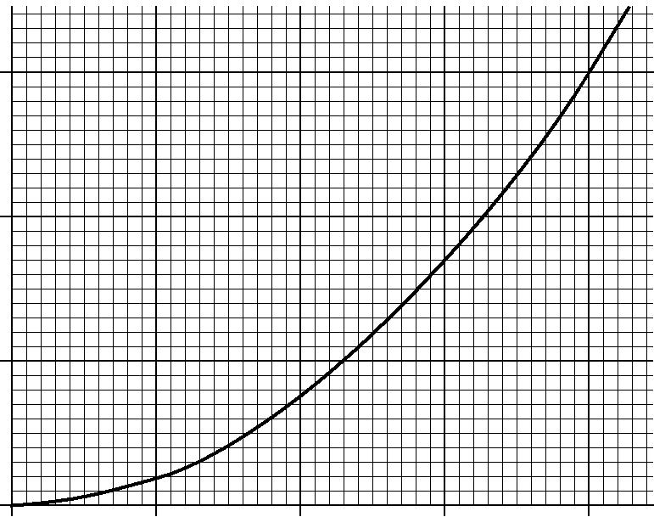

30

braking distance / m

20

10

0
0 | 5 | 10 | 15 | 20

v / m s^{–1}

Fig. 5.1

(i) The car is travelling on a level straight road at a speed of 20 m s^{–1}. The reaction time of the driver is 0.50 s.

1 Calculate the thinking distance.

thinking distance = ........................................................... m

2 Hence, determine the stopping distance of the car.

stopping distance = ........................................................... m

[3]

- In Fig. 5.1, the braking distance is directly proportional to the square of the speed. Determine the braking distance of the car when travelling at a speed of 32 m s^{–1}.

braking distance = .................................................... m [2]

2 A driver travelling in a car on a straight and level road sees an obstacle in the road ahead and applies the brakes until the car stops. The initial speed of the car is 20 m s^{–1}. The reaction time of the driver is 0.50 s.

Fig. 2. shows the velocity against time graph for the car.
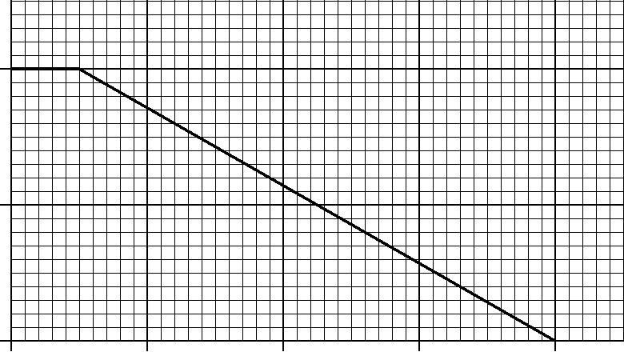

20
velocity / m s^{–1}
10
0
0 | 1.0 | 2.0 | 3.0 | 4.0
 |  | time / s

Fig. 2

- Define thinking distance.

...................................................................................................................................................

............................................................................................................................................ [1]

(b) What does the area under a velocity against time graph represent?

............................................................................................................................................ [1]

- Use your answer to (b) and Fig. 2.1 to determine

  - the thinking distance

thinking distance = .................................................... m [1]

- the braking distance.

braking distance = .................................................... m [2]

- The total mass of the car is 910 kg. Use Fig. 2.1 to determine

  - the magnitude of the deceleration of the car

deceleration = ............................................... m s^{–2} [2]

- the braking force acting on the car as it decelerates.

force = ..................................................... N [2]

- Suppose the initial speed of the car is twice that shown in Fig. 2.1. The braking force remains the same. State and explain by what factor the braking distance would increase.

...................................................................................................................................................

...................................................................................................................................................

...................................................................................................................................................

............................................................................................................................................ [2]

17. Hooke’s Law
Independent Study tasks this week:
Notes: | Completed
Make revision notes/cards on Hooke’s Law and Elastic Potential Energy
Independent Study Preparation task:  Read PAG instructions in preparation for practical Q:\Physics\Year 12 Mechanics\18.Springs in series and parallel PAG\Physics_Student_Sheet_2.2_Springs_in_Series_and_Parallel_v1.1.docx | C
Isaac Physics
Read concept board on Hooke’s law and answer practice questions
Independent Study Practice Questions:  complete all the questions in the spaces provided | C
1 Fig. 1 shows a mechanism for firing a table tennis ball vertically into the air.
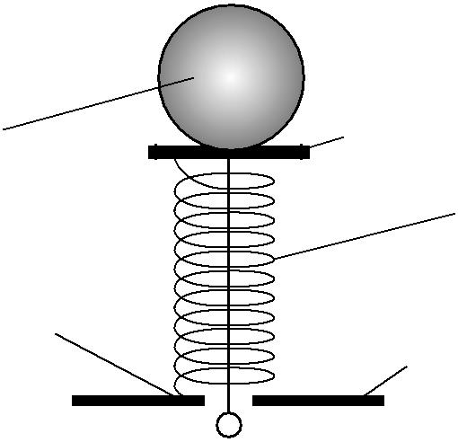

ball platform

spring

spring fixed
to plate
plate

pull and release to fire ball

Fig. 1

The spring has a force constant of 75 Nm^{–1}. The ball is placed on the platform at the top of the spring.

- The spring is compressed by 0.085 m by pulling the platform. Calculate the force exerted by the compressed spring on the ball immediately after the spring is released. Assume both the spring and the platform have negligible mass.

force = .......................................................N [2]

- The mass of the ball is 2.5 × 10^{–3} kg. Calculate the initial acceleration of the ball.

acceleration = ................................................. ms^{–2} [3]

- Calculate the maximum height that could be gained by the ball. Assume all the elastic potential energy of the spring is converted into gravitational potential energy of the ball.

height = ...................................................... m

[3]

2 The force against length graph for a spring is shown in Fig. 2.

6
force/N
5
4
3
2
1
0₀ | 2 | 4 | 6 | 8 | 10 | 12
 |  |  |  |  | length/10^{–2}m
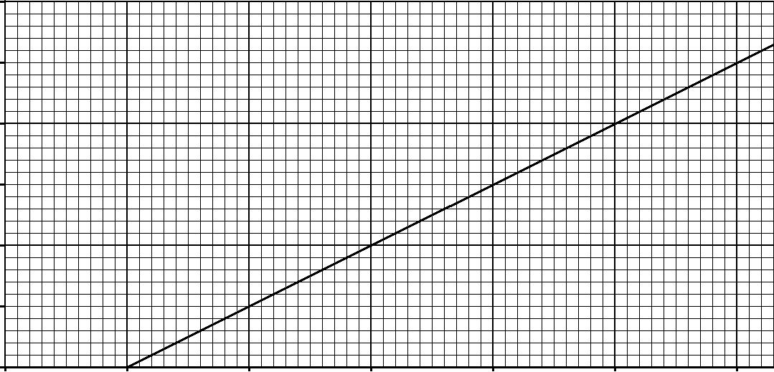
Fig. 2

- Explain why the graph does not pass through the origin.

...................................................................................................................................................

.............................................................................................................................................. [1]

- State what feature of the graph shows that the spring obeys Hooke’s law.

...................................................................................................................................................

.............................................................................................................................................. [1]

- Determine the force constant of the spring.

force constant = .......................................unit………….. [3]

- The gradient of the graph is equal to the force constant k of the spring. Determine the force constant of the spring.

force constant = ............................................... N m^{–1} [2]

3 (a) Atoms in a solid are held in position by electrical forces. These electrical forces can be represented by an imaginary ‘interatomic spring’ between neighbouring atoms, see Fig. 7.1.

‘interatomic spring’ atom
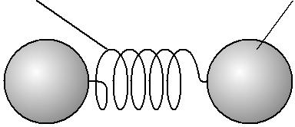

Fig. 7.1

The interatomic spring obeys Hooke’s law and has a force constant just as a normal spring in the laboratory. Researchers in America have recently managed to determine the force experienced by an individual atom of cobalt when the atoms are squeezed together. The researchers found that a force of 210 pN changed the separation between a pair of atoms by a distance of 0.16 nm.

- State Hooke’s law.
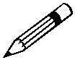
In your answer, you should use appropriate technical terms, spelled correctly.

...........................................................................................................................................

...........................................................................................................................................

...................................................................................................................................... [1]

- Calculate the force constant of the interatomic spring for a pair of cobalt atoms.

force constant = ..................................... N m^{–1} [3]

- (a) Fig. 4 shows a force against extension graph for a spring.

force
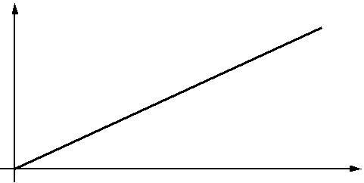

0
0 extension

Fig. 4

Describe how such a force against extension graph can be used to determine

- the force constant of the spring

In your answer, you should use appropriate technical terms, spelled correctly.

...........................................................................................................................................
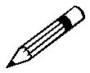
...................................................................................................................................... [1]

- the work done on the spring.

...........................................................................................................................................

...................................................................................................................................... [1]

- Two identical springs are connected end-to-end (series). The force constant of each spring is k. The free ends of the springs are pulled apart as shown in Fig. 4.1
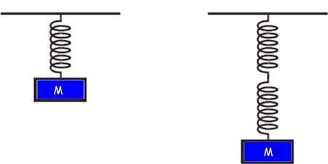
Pull
Pull
Fig 4.1

Explain why the force constant of this combination of two springs in series is ½ k..

..........................................................................................................................................................

..........................................................................................................................................................

..................................................................................................................................................... [2]

18. Springs in Series and Parallel PAG
Independent Study tasks this week:
Notes: | Completed
Make revision notes/cards on the Springs in Series and Parallel PAG
Independent Study Preparation task:  Read instructions and be ready to complete Young Modulus PAG Q:\Physics\Year 12 Mechanics\20. Measurement of Young Modulus PAG\Physics_Student_Sheet_2.1_Determining_Young_Modulus_v1.1.docx | C
Isaac Physics
Complete ‘springs’ gameboard
Independent Study Practice Questions:  Complete the activities outlined below in the space provided. | C

- Read text book p92 and write definitions for the following including any equations and units.
Tensile stress:
………………………………………..………………………………………..……………………………
………………………………………..………………………………………..……………………………
………………………………………..………………………………………..……………………………
………………………………………..………………………………………..……………………………
Tensile strain:
………………………………………..………………………………………..……………………………
………………………………………..………………………………………..……………………………
………………………………………..………………………………………..……………………………
………………………………………..………………………………………..……………………………
Young Modulus:
………………………………………..………………………………………..……………………………
………………………………………..………………………………………..……………………………
………………………………………..………………………………………..……………………………
………………………………………..………………………………………..……………………………

- TAP 228- 7: Calculations on stress, strain and the Young modulus
Practice questions
These are provided so that you become more confident with the quantities involved, and with the large and small numbers.

Try these
A strip of rubber originally 75 mm long is stretched until it is 100 mm long.
1. What is the tensile strain?

2. Why has the answer no units?

3. The greatest tensile stress which steel of a particular sort can withstand without breaking is about 109 N m-2. A wire of cross-sectional area 0.01 mm2 is made of this steel. What is the greatest force that it can withstand?

4. Find the minimum diameter of an alloy cable, tensile strength 75 MPa, needed to support a load of 15 kN.

5. Calculate the tensile stress in a suspension bridge supporting cable, of diameter of 50 mm, which pulls up on the roadway with a force of 4 kN.

6. Calculate the tensile stress in a nylon fishing line of diameter 0.36 mm which a fish is pulling with a force of 20 N

7. A large crane has a steel lifting cable of diameter 36 mm. The steel used has a Young modulus of 200 GPa. When the crane is used to lift 20 kN, the unstretched cable length is 25.0 m. Calculate the extension of the cable.

- Research and plan an experiment to investigate the value of the force constant when springs are in series and parallel.
You will need to include:
A labelled diagram of the equipment you would use.
Detailed explanations of the measurements you would take, how they would be taken and how those measurements will be used to answer the aim of the experiment.
You should explain how to carry out the procedure and include details to ensure safety and to reduce uncertainty in measurements.

- Read and make notes on the different descriptions for material properties and match up the correct descriptions to the words in the activity.
Q:\Physics\Year 12 Mechanics\19. Stress Strain and Young's Modulus\Material Property Definitions.docx
Q:\Physics\Year 12 Mechanics\19. Stress Strain and Young's Modulus\Material property definitions matching.pdf

19. Young Modulus
Independent Study tasks this week:
Notes: | Completed
Make revision notes/cards on Young Modulus
Independent Study task:  Read textbook p94&95 and make notes including the diagram for the second Young Modulus experiment. You might be asked to reproduce this method in your exam so it is wise to learn this (and all PAG practicals) | C
Isaac Physics
Read concept page on Young Modulus
Independent Study Practice Questions:  Complete all questions in the spaces provided | C

1 (a) On the axes of Fig. 7.1, sketch a stress against strain graph for a typical ductile material.

stress

 | 0
 | 0 |  |  | strain
 | 0
 |  |  | Fig. 7.1
 |  |  |  |  |  | [2]
(b) Circle from the list below a material that is ductile.
jelly |  | copper | ceramic | glass |  | [1]
- Define ultimate tensile strength of a material.

.............................................................................................................................................

............................................................................................................................................ [1]

- State Hooke’s law.

............................................................................................................................................

............................................................................................................................................ [1]

2 A lift has a mass of 500 kg. It is designed to carry a maximum of 8 people of total mass 560 kg. The lift is supported by a steel cable of cross-sectional area 3.8 × 10^{–4} m². When the lift is at ground floor level the cable is at its maximum length of 140 m, as shown in Fig. 3.1. The mass per unit length of the cable is 3.0 kg m^{–1}.
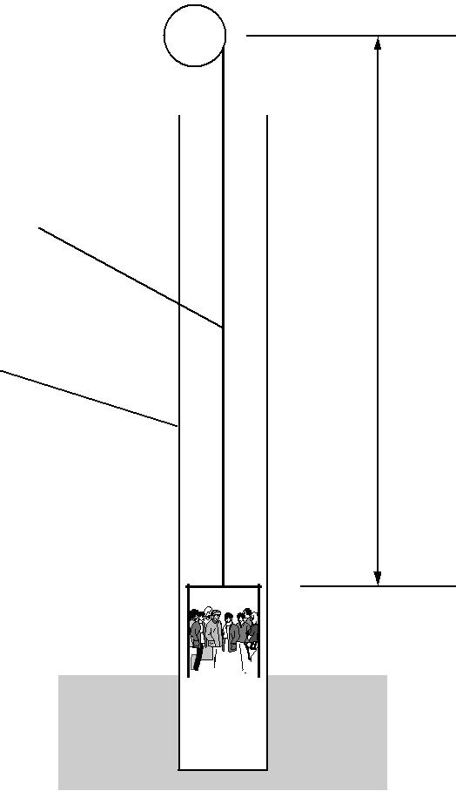

P

steel cable

140 m

lift shaft

ground floor 

Fig. 3.1

(a) Show that the mass of the 140 m long steel cable is 420 kg.

[1]

- (i) The lift with its 8 passengers is stationary at the ground floor level. The initial upward acceleration of the lift and the cable is 1.8 ms^{–2}. Show that the maximum tension in the cable at point P is 1.7 × 10⁴ N.

[4]

- Calculate the maximum stress in the cable. The Young’s modulus of the cable is 1.90 x 10¹¹Pa.

stress = .................................................... Pa [2]

(iii) Calculate the extension of the cable when the tension of the cable is at its maximum value.

…………………………………………..

[4]

3 (a) Fig. 7.1 shows a length of tape under tension.
pull |  | B |  | pull
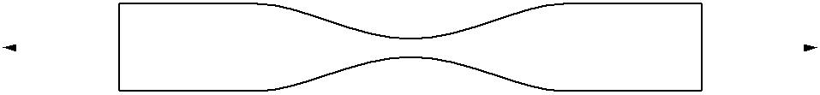

Fig. 7.1

- Explain why the tape is most likely to break at point B.

....................................................................................................................................

...................................................................................................................................... [2]

- Explain what is meant by the statement: ‘the tape has gone beyond its elastic limit’.
....................................................................................................................................

....................................................................................................................................

..................................................................................................................................... [1]

- Fig. 3 shows one possible method for determining the Young modulus of a metal in the form of a wire.

wood blocks | clamp | metal wire | marker
wood blocks |  | metal wire | pulley
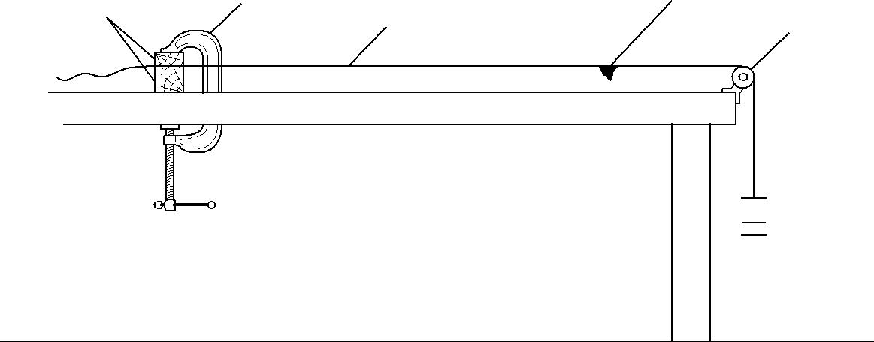

BENCH TOP

 masses

Fig. 3

Using your text book p94 & 95 describe how you can use this apparatus to determine the Young modulus of the metal. The sections below will be helpful when writing your answers. Write legibly.

The equipment used to take the measurements:

...................................................................................................................................................

...................................................................................................................................................

...................................................................................................................................................

...................................................................................................................................................

...................................................................................................................................................

...................................................................................................................................................

The measurements to be taken:

...................................................................................................................................................

...................................................................................................................................................

...................................................................................................................................................

...................................................................................................................................................

...................................................................................................................................................

...................................................................................................................................................

How you would determine Young modulus from your measurements:

...................................................................................................................................................

...................................................................................................................................................

...................................................................................................................................................

...................................................................................................................................................

...................................................................................................................................................

...................................................................................................................................................
[8]

4 (a) Fig. 4 shows stress against strain graphs for two materials X and Y up to their breaking points.
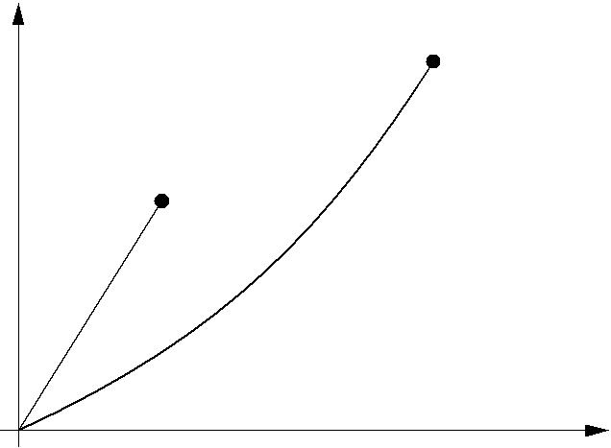

Y

X
stress

0
0
strain

Fig. 4

Put a tick (✓) in the appropriate column if the statement applies to the material.

Statement | X | Y
This material is brittle.
This material has greater breaking stress.
This material obeys Hooke’s Law.

[1]

- Kevlar is one of the strongest man-made materials. It is used in reinforcing boat hulls, aircraft, tyres and bullet-proof vests. Sudden impacts cause this material to undergo plastic deformation.

  - Explain what is meant by plastic deformation.

....................................................................................................................................

....................................................................................................................................

.................................................................................................................................... [1]

(ii) One particular type of Kevlar has breaking stress 3.00 GPa and Young modulus 1.30 GPa.

For a Kevlar thread of cross-sectional area 1.02 x 10⁻⁷ m² and length 0.500 m, calculate

1 the maximum breaking force

force = ........................................................... N

2 the extension of the thread when the stress is 1.20 GPa.

extension = ........................................................... m

[4]
20. Breaking Stress and Materials Test
Independent Study tasks this week:
Notes: | Completed
Make revision notes/cards on all the materials topics | C
Independent Study task:  Complete the past paper questions to revise for an end of topic test.  Q:\Physics\Year 12 Mechanics\Revision resources\3 Materials resources\Revision questions for Materials topic.docx | C
Isaac Physics
Complete concept pages on Materials topics – Hooke’s Law and Young Modulus
Independent Study Practice Questions:
Complete the activity below

Read the instructions for the ‘Breaking Stress’ experiment. Q:\Physics\Year 12 Mechanics\21. Breaking stress of Al Practical\Breaking stress of Aluminium.pdf
Make a revision resource highlighting the important features of this experiment. Remember to include:
Safety,
Equipment
Method to secure material & to take measurements.
Analysis – what will you do with the measurements?
How will you improve reliability?
What precautions would you take to improve accuracy?

