BWS A’ Level Physics
Year 12 Independent Study Quantum Booklet
Write all your answers in the spaces provided and use additional sheets where necessary.
This booklet is available for download on the website but may be updated so check you have an up to date copy.
A C by a certain activity indicates this is compulsory and must be completed ready for the next week as your lessons may depend on your ability to follow certain techniques or content.
Finally this booklet must be available for inspection at all times in your file.
Grade boundaries throughout for consolidation work are:
- A 80%
- B 70%
- C 60%
- D 50%
- E 40%
- U <40%

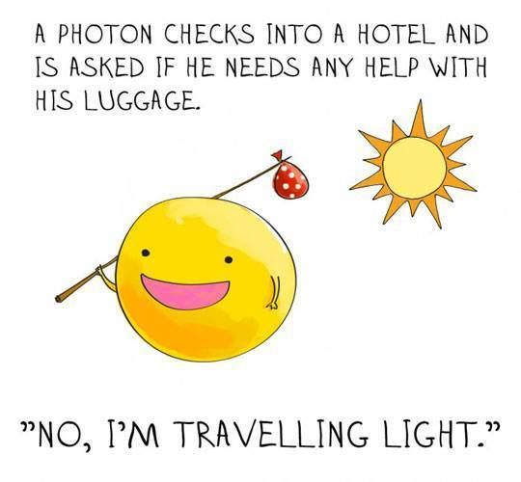

Week | Topic | Prep / Consolidation | Practice |  |  | Target Areas for improvement
Week | Topic | Prep / Consolidation | Complete | Practice Mark and Grade | Corrected | Target Areas for improvement
 | Measuring Planck’s Constant PAG |  |  | / 20 Grade:
 | Photoelectric Effect |  |  | / 35 Grade:
 | Stopping potential |  |  | / 20 Grade:
 | Wave Particle Duality |  |  | / 15 Grade:
 | Quantum Test |  |  | / Grade:

Measuring Planck’s Constant PAG
Independent Study tasks this week:
Notes: | Completed
Make revision notes/cards on Photons, Quanta, Planck’s constant PAG
Independent Study Learning Consolidation task:  Print out and read the instructions for the PAG to measure Planck’s constant  Q:\Physics\Year 12 Waves\Quantum Physics\2. Planck's Constant PAG\Measuring Plancks constant.pdf  Create a revision resource to help learn the key parts of the practical. | C
Isaac Physics
Read concept pages on Photoelectric effect and experimental evidence
Independent Study Practice Questions:  complete all the questions in the spaces provided | C

You may need to research the answers to some questions and use your text book to help you.
- What is a photon?

- Gamma rays from a radioactive material have higher frequency than visible light. Explain why this is including any relevant equations which support your answer.

- A light-emitting diode emits red light of wavelength 6.4 x ¹⁰⁻7m. Calculate:
- The frequency of the red light;

- The energy of a photon of red light.

- The electron-volt is a convenient unit of energy for particles and photon. Define the electron-volt.

- An electron is accelerated through a potential difference of 6.0V. According to a student, this electron has kinetic energy much greater than the energy of a photon of ultraviolet radiation of wavelength 2.5x10⁻⁷m. With the aid of calculations, explain whether or not the student is correct.

- a. Sketch the I-V characteristics for an LED that emits red photons and one that emits blue photons on the same axes.(You will need to read and apply p 244 & 245 to help you).

b. Explain the difference in threshold p.d. for each colour

Photoelectric Effect
Independent Study tasks this week:
Notes: | Completed
Make revision notes/cards on Photoelectric Effect
Independent Study Learning Preparation task:  Use the following website to consolidate learning from the classroom http://www.antonine-education.co.uk/Pages/Physics_1/Quantum/QP01/Quantum_1.htm | C
Isaac Physics
Read concept pages on Photoelectric effect and experimental evidence
Independent Study Practice Questions:  complete all the questions in the spaces provided | C

- Gold Leaf Electroscope experiment:
Describe what happens when:

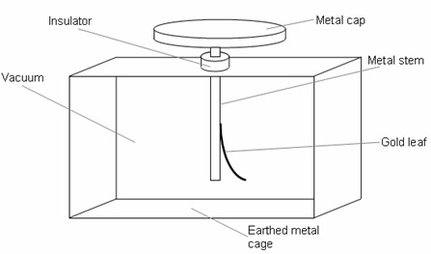
- You shine visible light on the negatively charged gold leaf electroscope.

- You shine ultraviolet light on the negatively charged gold leaf electroscope.

Explain why the results of this experiment can not be explained by the wave model of light.

What are the three observations made when this experiment is carried out for a range of frequencies and intensities of electromagnetic radiation.
1.

2.

3.

What is a Photon?

What did Albert Einstein discover about the relationship between the energy of photons and the frequency of radiation when looking at black body radiation?

What is Einstein’s (Nobel Prize Winning) equation for Photon Energy (name each symbol and give appropriate values for constants & the units)

Calculate the energy of…
- A gamma photon with a frequency of 3 x 10²⁰ Hz.

- A photon of light with wavelength of 400nm.

Explain how to convert photon energy in Joules to electronvolts (eV) and vice versa.

Calculate the energy of the following in eV…
- A gamma photon with a frequency of 3 x 10²⁰ Hz.

- A photon of light with wavelength of 400nm.

Using the wave equation (with c as speed of light) and the photon energy equation, derive an equation for the photon energy in terms of the speed, wavelength and planck’s constant.

How can we measure planck’s constant using LED’s? (Note you will have to re-read the instructions to the PAG in order to complete this question.

TAP 501-2: Photons streaming from a lamp
What to do
Complete the questions below. Provide clear statements of what you are estimating; show what calculations you are performing and how these give the answers you quote. Try to show a clear line of thinking through each stage.
Steps in the calculation
- Estimate the power of a reading lamp in watts.

- Estimate the average wavelength of a visible photon.

- Calculate the energy transferred by each photon.

- Calculate the number of photons emitted by the lamp in each second.

Stopping Potential
Independent Study tasks this week:
Notes: | Completed
Make revision notes/cards on the PAG to measure planck’s constant.
Look at the power point linked here and with your text book write notes to explain threshold frequency, the work function and the kinetic energy of emitted photoelectrons.
Q:\Physics\Year 12 Waves\Quantum Physics\1. Photoelectric effect\Photo-electric Effect animation.pptx
Independent Study Preparation task:  Follow the instructions in the powerpoint to complete a simulation practical. You will probably need to use the computer system at school to allow the simulation to work- it often does not work on home computers.  Q:\Physics\Year 12 Waves\Quantum Physics\3. Vacuum Photocell\Stopping Potential simulation task.pptx | C
Isaac Physics
Complete ‘questions D6 The Photoelectric Effect
Independent Study Practice Questions:  Complete all the tasks in the spaces provided. | C

- Read the following question carefully there are 6 marks available.
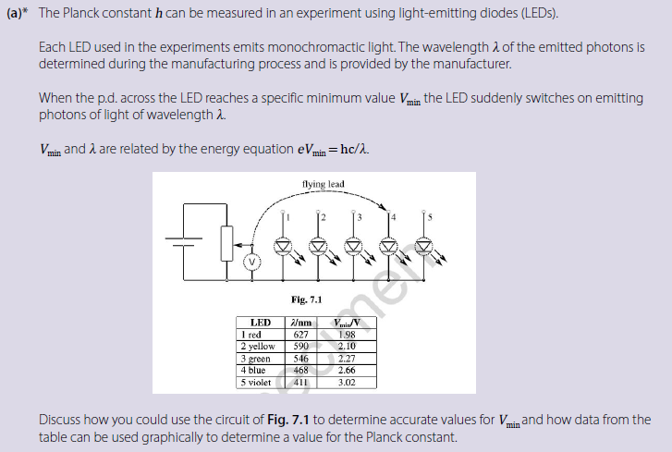

Now read the following examples of students’ answers, then, using the marking scheme annotate each answer to identify which marking points each answer has gained.
Give each answer a final mark (out of 6) and explain why you have come to that decision.

Candidate 1:
You would connect the flying lead to each LED independently, and then vary the voltage until the light starts to show. This is the minimum voltage, threshold frequency. Next you would need to plot a v against 1/λ graph. The wavelength value is provided, so no need to calculate it. The gradient of your graph would equal hc/e. To get Planck’s constant from this you would multiply your gradient by e, then divide by c. The graph should show a straight line which passes through the origin.
Total Mark awarded /6 = _________
Justification of mark
………………………………………………………………………………………………………………………………………………………………………………………………………………………………………………
………………………………………………………………………………………………………………………………………………………………………………………………………………………………………………
………………………………………………………………………………………………………………………………………………………………………………………………………………………………………………

Candidate 2:
Use a darkened roll of paper to look at LED or use a darkroom so you can see when it just comes on. Connect flying lead to 1. Decrease rheostat from max resistance downwards. Read p.d. on when just lights.
V
Repeat 5 times and take average.
Repeat with flying lead connected to 2 – 5.
$eV_{m}= \frac{hc}{λ}→V_{m}= \frac{hc}{e}×\frac{1}{λ}$
V_{min}
1/λ
Plot $gradient =\frac{hc}{e}$
$$∴h= \frac{e}{c }×gradient$$

Total Mark awarded /6 = _________
Justification of mark
………………………………………………………………………………………………………………………………………………………………………………………………………………………………………………
………………………………………………………………………………………………………………………………………………………………………………………………………………………………………………
………………………………………………………………………………………………………………………………………………………………………………………………………………………………………………

Candidate 3:
The variable resistor could be set to max then slowly decreased until LED 1 (red, requiring a lower voltage as it has a larger wavelength) begins to emit light. The reading on the voltmeter at this point is the potential difference required to “just” turn on the LED, the specific minimum V_{min}. This could be repeated for all the LED’s to obtain the data shown in the table.
$$If eV_{min}=\frac{hc}{λ}, then V_{min}=\frac{hc}{e}×λ^{-1}$$
If we plot a graph of V (p.d) to λ⁻¹, the gradient of this graph would be equal to hc/e

Total Mark awarded /6 = _________
Justification of mark
………………………………………………………………………………………………………………………………………………………………………………………………………………………………………………
………………………………………………………………………………………………………………………………………………………………………………………………………………………………………………
………………………………………………………………………………………………………………………………………………………………………………………………………………………………………………

Marking criteria:
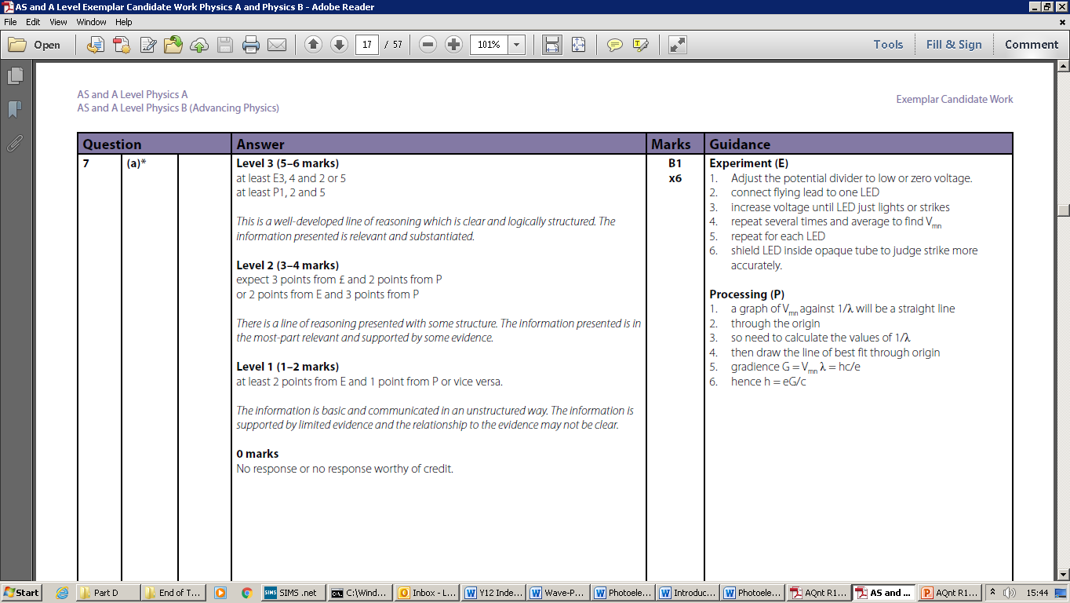

Photoelectric effect questions

1 The work function for lithium is 4.6 x 10⁻¹⁹ J.
- Calculate the lowest frequency of light that will cause photoelectric emission.

(b) What is the maximum energy of the electrons emitted when light of 7.3 x 10¹⁴ Hz is used?

2 The stopping potential when a frequency of 1.61 x 10¹⁵ Hz is shone on a metal is 3 V.
- What is energy transferred by each photon?

- Calculate the work function of the metal.

- What is the maximum speed of the ejected electrons?

3 Selenium has a work function of 5.11 eV. What frequency of light would just eject electrons? (The threshold frequency is when the max KE of the ejected electrons is zero)

4 A frequency of 2.4 x 10¹⁵ Hz is used on magnesium with work function of 3.7 eV.
- What is energy transferred by each photon?

- Calculate the maximum KE of the ejected electrons.

- The maximum speed of the electrons.

- The stopping potential for the electrons.

Wave Particle Duality
Independent Study tasks this week:
Notes: | Completed
Make revision notes/card on the vacuum photocell and stopping potential and Wave Particle Duality and revise for a test. | C
Independent Study Consolidation task:  Complete revision questions to prepare for a test on Quantum Physics  Q:\Physics\Year 12 Waves\Quantum Physics\5. Revision\Quantum Revision Questions and MS.docx | C
Isaac Physics
Complete questions D6 The Photoelectric effect (if not completed already) and D7 Quantum calculations.
Independent Study Practice Questions:  Complete these questions below | C

- A clean magnesium surface is supported in a vacuum as the cathode of a photocell. A wire-mesh electrode surrounds the cathode and is used as the anode. When the cathode is illuminated with ultraviolet radiation of wavelength 254nm, the anode current can be reduced to zero by making it negative with respect to the cathode using a p.d. of 1.2V or greater. Obtain a value for the work function of magnesium in electron-volts.

- Radiation of frequency 9.0 x 10¹⁴ Hz falls on the cathode of a photocell. The material of the cathode has a threshold frequency of 4.0 x 10¹⁴ Hz. What is the maximum energy, in J of the emitted electrons?

- A ball of mass 50g travels through an open door of width 1m at a velocity of 6.0ms⁻¹
- Calculate its de Broglie wavelength.

- Use your answer to a to explain why the ball fails to show observable diffraction effects.

TAP 506- 4: Electron diffraction questions

1 In an electron diffraction experiment using graphite the larger ring formed by rows of carbon atoms 1.23 x 10⁻¹⁰ m apart was formed at an angle of 0.167 radian.

(a) What is the wavelength? [θ in radians = λ / b where b is the diffracting object size]

(b) Write an expression for the kinetic energy of an electron (½ mv²) in terms of its charge, and accelerating voltage V

(c) Obtain an expression for momentum, p, in terms of e, V and m.

The accelerating voltage was 5000 V
(d) Work out h in mv = h/ λ

