BWS A’ Level Physics
Year 12 Independent Study Booklet
Waves I
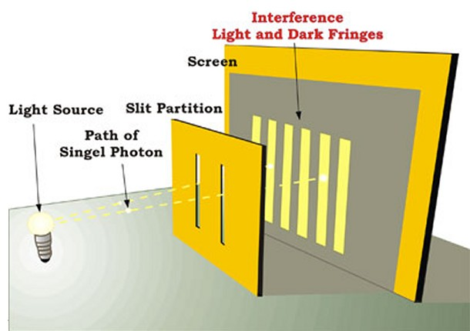

Write all your answers in the spaces provided and use additional sheets where necessary.
This booklet is available for download on the website but may be updated so check you have an up to date copy.
COMPULSORY by a certain activity indicates this task must be completed ready for the time stated as your lessons that week may depend on your ability to complete certain techniques or know certain content.
Finally this booklet must be available for inspection at all times in your file.
Grade boundaries throughout for practise questions are:
- A 80%
- B 70%
- C 60%
- D 50%
- E 40%
- U <40%

Week | Topic | Prep / Consolidation | Practice |  |  | Target Areas for improvement
Week | Topic | Prep / Consolidation | Complete | Practice Mark and Grade | Corrected | Target Areas for improvement
1 | GCSE Waves Recap |  |  | / 36 Grade:
2 | Refraction, TIR & Diffraction |  |  | / 34 Grade:
3 | Polarisation and intensity |  |  | / 50 Grade:
4 | Superposition and Interference |  |  | / 37 Grade:
5 | Young’s Double Slit |  |  | / 20 Grade:
6 | Standing Waves |  |  | / 47 Grade:

GCSE Waves Recap
Notes / Revision Preparation: | Completed
Complete the table on EM waves (below). You may find these resources helpful;  - http://science.hq.nasa.gov/kids/imagers/ems/radio.html  - http://www.purchon.com/physics/electromagnetic.htm  - http://www.darvill.clara.net/emag/index.htm  - http://www.skincancer.org/understanding-uva-and-uvb.html | *compulsory
Independent Study Learning Preparation task:  Describe the effects of UV-A, UV-B and UV-C radiation on living cells and how the ozone layer and sunscreen can protect us. | *compulsory
Isaac Physics
Read the concept page on EM spectrum;
https://isaacphysics.org/concepts/cp_em_waves
Independent Study Practice Questions:  Complete all the questions in the spaces provided | *compulsory

1. The table below shows some information about various radio stations. Fill in the missing information.
 | Frequency | Wavelength
Plastic Soul FM | 95.3 MHz
Dave FM |  | 326 cm
80s All Day | 187 kHz
Frere Jacques |  | 1700 m
[4]
2. The diagrams below show rays of light refracting as they enter glass and water.
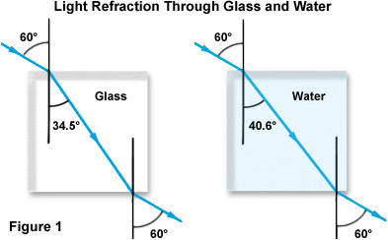
(a) Using the diagrams above calculate the refractive index for both glass and water.

Refractive index of glass……………………………….
Refractive index of water...……………………………..
[3]

(b) The angle of incidence is now changed to 30 degrees for both. Calculate the angle of refraction for both glass and water.

Angle of refraction for glass ………………………
Angle of refraction for water ……………………..
[4]

(c) Calculate the speed of light in both the water and the glass.

Speed of light in glass …………………………………
Speed of light in water………………………………..
[3]
(d) Calculate the critical angle for the water.

….…………………. [2]
(e) (i) Light passes from water towards air with an angle of incidence of 25 degrees. Draw a sketch to show this situation in the space below.

[2]
(ii) The angle of incidence is increased to 50 degrees. Add rays showing this situation to your diagram above. [2]
3. The diagram below shows a transverse wave on an oscilloscope. The x-axis is set to 0.5 ms per division.
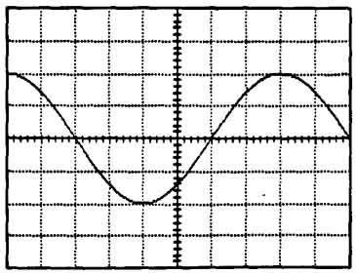

(a) Calculate the frequency of the wave trace shown

……………………..unit………………
[3]
(b) On the same diagram, sketch a wave with:
(i) twice the frequency but the same amplitude.
(ii) Half the amplitude and half the frequency.
[4]

4. Which group of electromagnetic waves is arranged in order of increasing frequency?
lowest frequency highest frequency

A | gamma rays, ultra-violet rays, radio waves
B | microwaves, ultra-violet rays, X-rays
C | radio waves, visible light, infra-red radiation
D | Visible light, infra-red radiation, microwaves
[1]
5. A ray of light passes from air into a rectangular glass block.
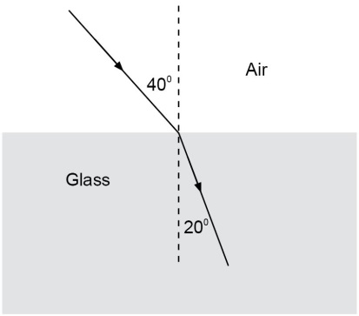
The refractive index of the glass is:
A | 0.53
B | 0.82
C | 1.2
D | 1.9
[1]
6. The y-input terminals of an oscilloscope are connected to a voltage supply of peak value 5.0 V and frequency 50 Hz.
The time-base is set at 10 ms per division and the y axis is set at 5.0 V per division.
Assuming that these diagrams are to scale, which trace will be obtained?

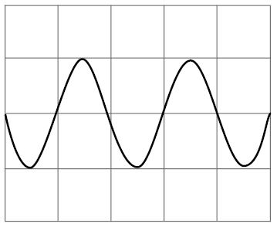  A  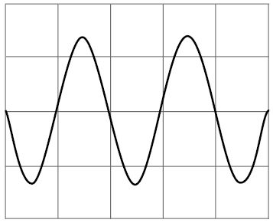  C | 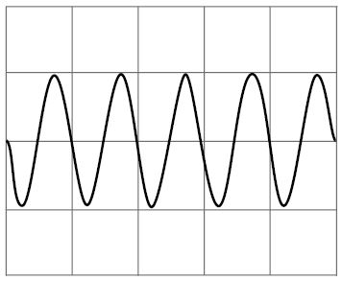  B  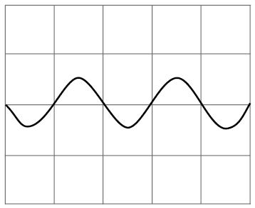  D
[1]

7. In this question take the speed of sound in air to be 330 ms⁻¹ and the speed of light in a vacuum to be 3 × 10⁸ ms⁻¹
- Two people are talking via a communications satellite link between Birmingham and Manchester. They both notice a short pause before the start of the reply. The satellite
is positioned 4x 10⁷ m above the earth.
(i) Why does the pause occur?
…………………………………………………………………………………………………………………………………………………………………………………………………………………...…[1]
(ii) How long is the pause?

[2]

(b) A starting pistol is fired at an athletics event. A spectator in the stadium hears the sound 0.3 s later than seeing the smoke from the gun.
(i) Explain the delay in hearing the sound.
…………………………………………………………………………………………………………………………………………………………………………………………………………………...…[1]
(ii) How far is the spectator from the starting pistol?

[2]

Electromagnetic Spectrum
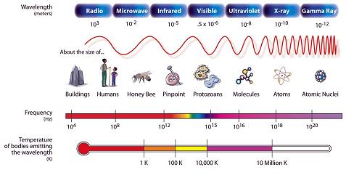

 | Wavelength Range | Frequency Range | Uses | Method of Production | Method of Detection
Radio
Microwave
Infrared
Visible
Ultraviolet
X-Ray
Gamma Ray

All EM waves travel at the speed of light in a vacuum, c, _____________
- They are __________ waves.
- They can be reflected, refracted or diffracted
- The amount of energy carried by an electromagnetic wave is a function of its wavelength.

Refraction, TIR and Diffraction
Notes / Revision Preparation: | Completed
Use the table of definitions shown on page 197 to create flash cards of core ideas.
Independent Study Learning Preparation task:
Describe and draw a diagram to show an experiment for each of the light properties listed on pages 203 – 204 (refraction of water waves, reflection, refraction).
Isaac Physics
Read the concept pages on reflection and refraction; you should aim to read all of the pages marked “Level 1”
https://isaacphysics.org/concepts/cp_reflection_and_refraction
Then try... https://isaacphysics.org/questions/refractive_index?board=56ccdcd4-b61b-494b-962a-7f973877796c
Independent Study Practice Questions:  Complete all the questions in the spaces provided | *compulsory

1. The graph below represents a progressive transverse wave:
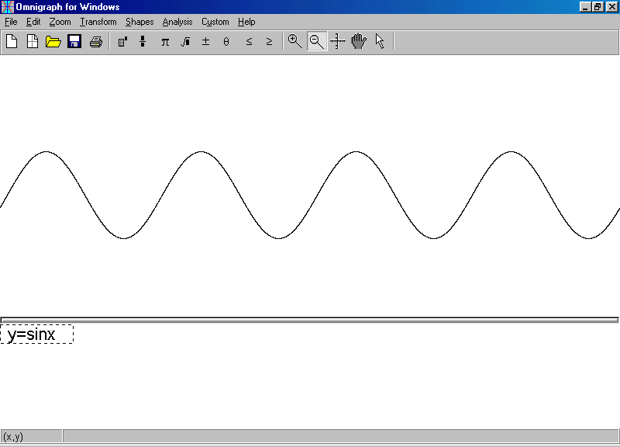
Displacement from equilibrium

Distance from source

(a) Label the following measurements on the appropriate graphs:
(i) Amplitude

(ii) Wavelength

(iii) Wave direction
[3]

2. A ray of light passes from air of refractive index 1 to water of refractive index 1.46. The angle of incidence is 30 degrees.
(a) (i) State Snell’s law
……………………………………………………………………………………………………………
………………………………………………………………………………………………………...[1]

(ii) Calculate the angle of refraction.

…………………………….[2]
(iii) Calculate the speed of light in the water.

…………………………..unit………….[2]

(c) The situation is now reversed so that the water passes from water into air with the same angle of incidence as before.
(i) Calculate the angle of refraction for this new situation.

……………………… [2]

(ii) Prove that the critical angle is given by the equation $n= \frac{1}{\sin{C}}$ where c is the critical angle.

[3]

(iii) Calculate the critical angle for the situation described above.

…………………………………………….[2]
(iv) State and justify what happens when the angle of incidence is increased to 50 degrees.

………………………………………………………………………………………………………………………………………………………………………………………………………………………………………………………………………………………………………………………………...…[2]
2. A fibre optic cable is constructed from a core and cladding, surrounded by a protective sheath. The core and cladding are transparent to light but the light only travels down the core.
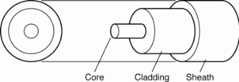

A perfectly straight fibre optic cable of length 1.0 km is shown below.
The core has a diameter of 50 μm.
(a) The refractive index of the core is 1.50 and the refractive index of the cladding is 1.05. Calculate the critical angle for the core-cladding boundary.

………………………………………….. [2]
(b) (i) Two possible paths of light are shown in the diagram above. Calculate the minimum possible time for the light to travel 1.0 km along the core.

……………………………….. unit…………..[3]

(ii) In the diagram the angle of incidence is 50 degrees. Calculate the time taken for a ray of light to travel along this path.

………………………………………unit…………..[5]
(iii) The chief engineer on the project proposes increasing the diameter of the core by 10% in order to reduce manufacturing costs. Discuss the effect of this change on the operation and effectiveness of the fibre optic cable.

……………………………………………………………………………………………………………
……………………………………………………………………………………………………………
……………………………………………………………………………………………………………
……………………………………………………………………………………………………………
……………………………………………………………………………………………………………
……………………………………………………………………………………………………………
……………………………………………………………………………………………………..….[3]
3. Draw diagrams to show how the diffraction of a plane wave front at a slit depends on the width of the slit.

[4]
Polarisation and Intensity

Notes / Revision Preparation: | Completed
Read pages 213 – 214 on Polarisation. Using the How Science Works Box (green) read about the experiment to determine the intensity of light which will be received through 2 polarisers. You will be completing this experiment! | *compulsory
Independent Study Learning Preparation task:
Use the video clips below as the base to learn how 3D cinemas create their images;
https://www.youtube.com/watch?v=E-nOXpVPAPs
Isaac Physics
Complete the question on Polarising Power – you may wish to read the concept page first.
https://isaacphysics.org/questions/polarised_power?board=d003fec9-a40e-4b59-a52c-186408073e77
Independent Study Practice Questions:  Complete all the questions in the spaces provided | *compulsory

- (a) (i) Both electromagnetic waves and sound waves can be reflected. State two other wave phenomena that apply to both electromagnetic waves and sound waves.

1……….........................................................................................................................................
2. ............................................................................................................................................ [2]

(ii) Explain why electromagnetic waves can be polarised but sound waves cannot be polarised

......................................................................................................................................................

.............................................................................................................................................. [1]

(iii) Describe briefly an experiment to demonstrate the polarisation of microwaves in the laboratory.
In your answer you should make clear how your observations demonstrate polarisation.

......................................................................................................................................................

......................................................................................................................................................

......................................................................................................................................................

..................................................................................................................................................[4]
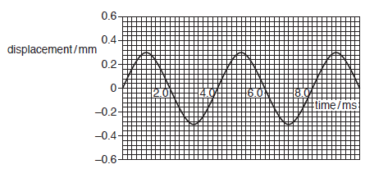
(b) A sound wave emitted by a loudspeaker consists of a single frequency. Fig. 4.1 shows the displacement against time graph of the air at a point P in front of the speaker.
(i) Use Fig. 4.1 to find
1 the amplitude of the air motion

amplitude = ................................................. mm [1]
2 the frequency of the sound wave.

frequency = ................................................... Hz [2]

(ii) The sound generator is adjusted so that the loudspeaker emits a sound at the original
frequency and half the intensity. Sketch on Fig. 4.2 the new displacement against time
graph at point P. Explain your reasoning.

...................................................................................................................................................

..................................................................................................................................................

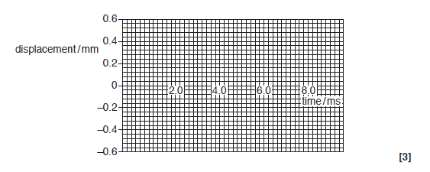
............................................................................................................................................... [2]
Total [15]
- The intensity of light falls as a 1/r² law. The total power output of a star is 6.0 x 10²⁶ W of which 5% is visible light. The star is at a distance of 200 light years from Earth.
a) Calculate the distance of the star in metres.

……………………………… m [3]

(b)(i) The minimum power that can be seen by the human eye is 10⁻¹⁷ W. The human eye may be considered as perfect circle of radius 3.0 mm.
Calculate the minimum intensity that can be seen by the human eye.

……………………………………….[4]

(ii) Calculate the maximum distance that a star of this power output can be seen by the naked eye.

Light years ……………………………………………….[4]

- The orbit of Mars is quite eccentric (elliptical). The actual distance between Mars and the Sun ranges between 2.478x10¹¹m and 2.084 x 10¹¹m.
To what extent will this change the intensity of solar radiation at the planet’s surface, at noon, throughout the Martian year? Express your answer as a ratio of the maximum to minimum intensities. Ignore any effects due to the atmosphere of Mars.

[4]
Total [15]
3. Mechanical waves are generated in a material medium by a repeated disturbance caused by an oscillating body.
(i) What are the two oscillations that form electromagnetic waves?

1

2 ……………………………………………………………………………………………… [2]

(ii) What is the geometrical arrangement of these oscillations with respect to each other?

………………………………………………………………………………………………… [1]

(iii) In what other way do electromagnetic waves differ from the mechanical waves described above?

…………………………………………………………………………………………………. [1]

(b) Name the main divisions of electromagnetic radiation in order of wavelength, starting with the largest wavelength.

…………………………………………………………………………………………………. [4]
(c) Select two of these types of electromagnetic radiation and state:
(i) The approximate range of their wavelengths

…………………………………………………………………………………………………. [2]

(c) (ii) A suitable source and detector for each.

………………………………………………………………………………………………… [4]

Total [14]
4. A puddle of water reflects sunlight. A student knows that reflected light is partially polarised. She looks at the reflected light from the puddle of water though a polarising filter.
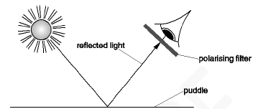
- Explain what is meant by the term polarised waves. You may wish to illustrate your answer with a labelled diagram.

……………………………………………………………………………………………………………………………………………………………………………………………………………….. [2]
- Describe how the student can use the polarising filter to determine if the reflected light from the puddle is partially polarised. State clearly what she should observe.

……………………………………………………………………………………………………………………………………………………………………………………………………………………
……………………………………………………………………………………………………………………………………………………………………………………………………………….. [3]
Total [5]

- A student views the display of a laptop screen through a polarising filter. The intensity of the light changes when the filter is rotated.

Which property of light is demonstrated in this experiment?

A It has wavelength of about 5 × 10^{–7} m. B It travels at the speed of light.

C It is a transverse wave.
D It is a longitudinal wave.
[1]

Superposition and Interference
Notes / Revision Preparation: | Completed
Review your notes on Interference from GCSE. You should know the key definitions such as; constructive, destructive and superpose and should be able to explain how the addition of displacements is used to calculate the resultant amplitude. | *compulsory
Independent Study Learning Preparation task:
Read pages 222-223 and answer the summary questions. You should be able to check your answers in the back of the book – make corrections where necessary.
Isaac Physics
Complete the question on Thin Film Colour using your ideas from interference. https://isaacphysics.org/questions/thin_film_colour?board=9b3b6c3d-062d-4e8f-9cf0-249a6b7dd0c7
Independent Study Practice Questions:  Complete all the questions in the spaces provided | *compulsory

- The diagram below shows the variation with time t of the displacements x_{S} and x_{T} at a point P of two sound waves S and T.
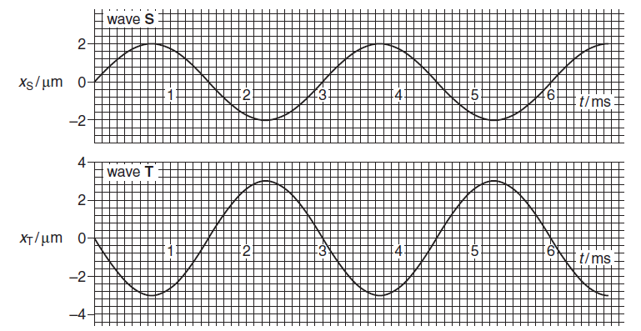
- By reference to the diagram, state one similarity and one difference between these two waves.
Similarity ..................................................................................................................................

Difference ........................................................................................................................... [2]

- Explain whether or not the two waves are coherent.

..................................................................................................................................................

...................................................................................................................................................

............................................................................................................................................. [2]

- The speed of the sound waves is 340 m s^{–1}. Determine the frequency of wave S and hence its wavelength.

frequency = ………………………………… Hz
wavelength = ................................................ | m [4]

- At point P the two sound waves superpose (combine). By reference to Fig. 4.1 determine the resultant displacement x of the two waves at time

  - t₁ = 1.5 ms

x₁ = ............................................. m [1]

(ii) t₂ = 2.25 ms.

x₂ = ............................................. m [1]

- The intensity of wave S alone at point P is I.

  - Show that the intensity of wave T alone at point P is 2.25 I.

[2]

- Calculate the intensity of the resultant wave at point P in terms of I.

intensity = ................................................. I [2]

- The sound waves shown in Fig. 4.1 are emitted from the loudspeakers labelled S and T in Fig. 4.2 and detected by the microphone at point P.

S
P
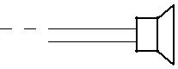
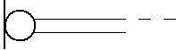

T
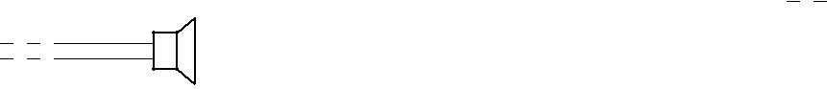

Fig. 4.2

- Calculate the distance that loudspeaker S must be moved towards P to bring the two waves into phase at P. State your reasoning clearly.

distance = .............................................. m [2]

- Describe how the intensity of the sound wave detected at P varies as loudspeaker S is moved as in (i).

..................................................................................................................................................

..................................................................................................................................................

.......................................................................................................................................... [2]

[Total: 18]

- (a) Explain what is meant by a progressive wave.

...................................................................................................................................................

...................................................................................................................................................

............................................................................................................................................. [2]

- Describe how a transverse wave differs from a longitudinal wave.

...................................................................................................................................................

...................................................................................................................................................

............................................................................................................................................. [2]

(c) (i) Explain what is meant by diffraction of a wave.

...................................................................................................................................................

............................................................................................................................................. [1]

- Describe how you would demonstrate that a sound wave of wavelength 0.10 m emitted from a loudspeaker can be diffracted.

.................................................................................................................................................

.................................................................................................................................................

.................................................................................................................................................

.................................................................................................................................................

.................................................................................................................................................

.................................................................................................................................................

............................................................................................................................................ [4]

Fig. 4.1 shows two loudspeakers connected to a signal generator, set to a frequency of 1.2 kHz. A person walks in the direction P to Q at a distance of 3.0 m from the loudspeakers.

loudspeakers | Q
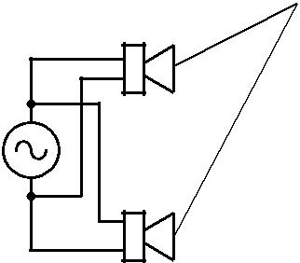

3.0 m P

Fig. 4.1

- Calculate the wavelength λ of the sound waves emitted from the loudspeakers. speed of sound in air = 340 m s^{–1}

λ = ..................................................... m [2]

- Explain, either in terms of path difference or phase difference, why the intensity of the sound heard varies as the person moves along PQ.

...........................................................................................................................................

...........................................................................................................................................

...........................................................................................................................................

...........................................................................................................................................

...........................................................................................................................................

...........................................................................................................................................

...........................................................................................................................................

...........................................................................................................................................

...........................................................................................................................................

...........................................................................................................................................

..................................................................................................................................... [3]

(iii) The distance x between adjacent positions of maximum sound is 0.50 m. Calculate the separation a between the loudspeakers. Assume that the equation used for the interference of light also applies to sound.

a = ..................................................... m [2]

(iv) The connections to one of the loudspeakers are reversed. Describe the similarities and differences in what the person hears.

.....................................................................................................................................................

.....................................................................................................................................................

.....................................................................................................................................................

....................................................................................................................................................

....................................................................................................................................................

.............................................................................................................................................. [2]

[Total: 18]

3. Water waves of wavelength 4 m are produced by two wave generators, S₁ and S₂, as shown.
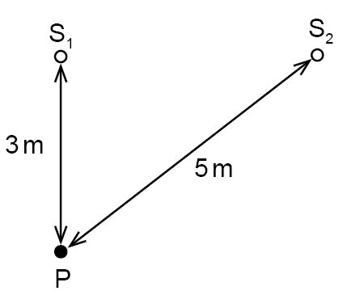
Each generator, when operated by itself, produces waves which have an amplitude A at P, which is 3m from S1 and 5m from S2.
When the generators are operated in phase, what is the amplitude of oscillation at P?
A | 0
B | ½ A
C | A
D | 2A
[1]
Youngs Double Slit

Notes / Revision Preparation: | Completed
Write a paragraph describing the difference between Young’s wave model and Newton’s corpuscle model for the nature of light | *compulsory
Independent Study Learning Preparation task:
Prepare an A4 page summary (including diagram) of Young’s Double Slit Experiment. You should include in your work;
- Diagram of apparatus
- Description and explanation of the observations made
- Calculations and conclusions Young made from his observations
Isaac Physics
Complete the question on Modified Double Slit:
https://isaacphysics.org/questions/modified_double_slit?board=44b933c0-411a-4ef9-b3fc-703de4d28f90
Independent Study Practice Questions:  Complete all the questions in the spaces provided | *compulsory

- (a) State the principle of superposition of waves.

...................................................................................................................................................

...................................................................................................................................................

.............................................................................................................................................. [2]

(b) Coherent red light of wavelength 6.00 × 10⁻⁷ m is incident normally on a pair of narrow slits S₁ and S₂. A pattern of bright and dark lines, called fringes, appears close to point P on a
distant viewing screen.
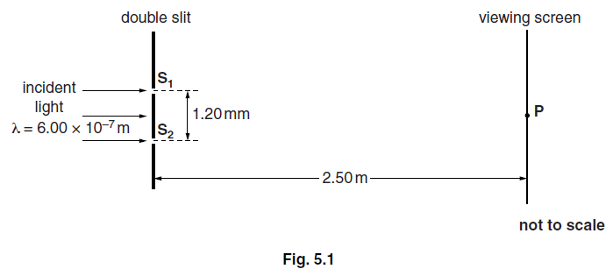

- Explain the term coherent.

...........................................................................................................................................

...........................................................................................................................................

...................................................................................................................................... [1]

- State a value of the path difference between the light waves from slits S₁ and S₂ to the screen to produce a dark fringe on the screen.

path difference = ..................................... m [1]

- Calculate the separation of adjacent dark fringes on the screen near to point P.

Use the following data: slit separation S₁S₂ = 1.20 mm
distance between slits and screen = 2.50 m

separation = .................................... m [3]

- State and explain the effect, if any, on the position of the bright fringes on the screen when each of the following changes is made, separately, to the apparatus.

  - The light source is changed from a red to a yellow light source.

...........................................................................................................................................

...........................................................................................................................................

...........................................................................................................................................

......................................................................................................................................................... [2]

2 Slit S₁ is made wider than slit S₂ but their centres remain the same distance apart.

.......................................................................................................................................................

......................................................................................................................................................

......................................................................................................................................................

......................................................................................................................................................... [2]

3 The viewing screen is moved closer to the slits.

.......................................................................................................................................................

......................................................................................................................................................

.......................................................................................................................................................

.......................................................................................................................................................... [2]

[Total: 13]

2. Light of wavelength 600 nm falls on a pair of slits, forming fringes 3.00 mm apart on a screen.
What would the fringe spacing become if the wavelength were 300 nm?
A | 0.75 mm
B | 1.50 mm
C | 3.00 mm
D | 6.00 mm
[1]

- (a) A student is investigating the interference of microwaves after passing through two narrow slits.
    - (i) State the principle of superposition of waves.

...........................................................................................................................................
...........................................................................................................................................
..................................................................................................................................... [1]
- For interference effects to be observed, the waves from the two slits must be coherent. State what is meant by the term coherent.

...........................................................................................................................................
...........................................................................................................................................
..................................................................................................................................... [1]

- A student sets up an experiment to demonstrate the interference of microwaves as shown in Fig. 2.
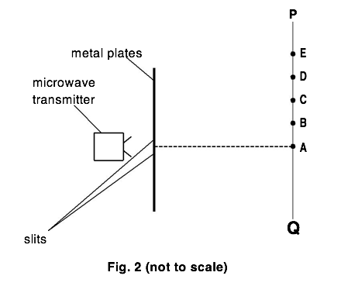
A microwave transmitter is placed in front of the two slits. A microwave detector is moved along the line PQ. Maxima are detected at points A, C, and E. Minima are detected at points B and D.

The distance travelled by the microwaves from each slit to point A is the same.
State the path difference in terms of the wavelength λ of the microwaves from the two slits at

- point C

path difference = ...............................................................

- point D

path difference = ...............................................................
[2]
- The separation between the slits is increased.

State and explain the effect this has on the separation between adjacent maxima.
...................................................................................................................................................
...................................................................................................................................................
................................................................................................................................................. [2]
[Total: 6]

Standing Waves

Notes / Revision Preparation: | Completed
After completing the determining the speed of sound using a resonance tube practical complete an uncertainties and error in experiments work sheet. | *compulsory
Independent Study Learning Preparation task:
CHECK WITH MUM/DAD BEFORE YOU DO THIS. Use your microwave at home and some jelly babies (or similar) to calculate the speed of light! Remember your melted patches represent anti-nodes which should happen every ½ wavelength. Warning – this may smell and put down kitchen towel first!!
Isaac Physics
Complete the questions on Standing Waves;
https://isaacphysics.org/questions/ch_d_p5
Independent Study Practice Questions:  Complete all the questions in the spaces provided | *compulsory

- Fig. 5.1 shows a uniform string which is kept under tension between a clamp and a pulley. The frequency of the mechanical oscillator close to one end is varied so that a stationary wave is set up on the string.

 | 0.45 m
X | Z
clamp | pulley
 | Y
oscillator | masses
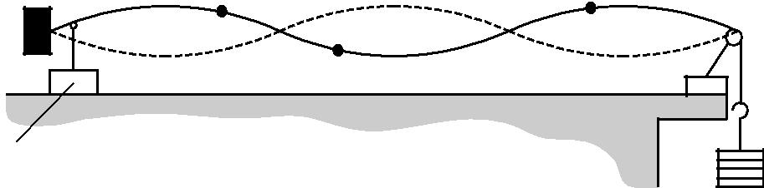

Fig. 5.1

- State two features of a stationary wave.

...................................................................................................................................................

...................................................................................................................................................

...................................................................................................................................................

............................................................................................................................................. [2]

- Explain how the stationary wave is formed on the string.

...................................................................................................................................................

...................................................................................................................................................

...................................................................................................................................................

...................................................................................................................................................

............................................................................................................................................. [2]

(c) The distance between the clamp and the pulley is 0.45 m. X, Y and Z are three points on the string. X and Y are each 0.040 m from the nearest node and Z is 0.090 m from the pulley. State, giving a reason for your choice, which of the points Y or Z or both oscillate

- with the same amplitude as X

...........................................................................................................................................

...........................................................................................................................................

...........................................................................................................................................

..................................................................................................................................... [2]

- with the same frequency as X

...........................................................................................................................................

...........................................................................................................................................

...........................................................................................................................................

..................................................................................................................................... [2]

- in phase with X.

...........................................................................................................................................

...........................................................................................................................................

...........................................................................................................................................

..................................................................................................................................... [2]

[Total: 10]

- (a) When used to describe stationary (standing) waves explain the terms

  - node .............................................................................................................................

...................................................................................................................................... [1]

(ii) antinode. ............................................................................................................................

...................................................................................................................................... [1]

Fig. 5.1 shows a string fixed at one end under tension. The frequency of the mechanical oscillator close to the fixed end is varied until a stationary wave is formed on the string.

90 cm
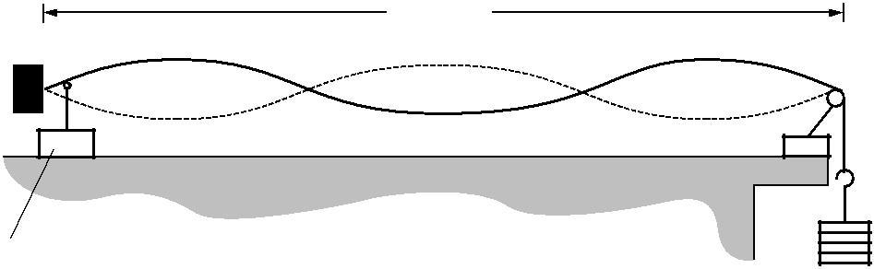
clamp | pulley

oscillator | masses

Fig. 5.1

- Explain with reference to a progressive wave on the string how the stationary wave is formed.

 | ...........................................................................................................................................
 | ...........................................................................................................................................
 | ...........................................................................................................................................
 | ...........................................................................................................................................
 | ...........................................................................................................................................
 | ...........................................................................................................................................
 | ...................................................................................................................................... | [3]
(iv) | On Fig. 5.1 label one node with the letter N and one antinode with the letter A. | [1]

- State the number of antinodes on the string in Fig. 5.1.

number of antinodes = ......................................................... [1]

- The frequency of the oscillator causing the stationary wave shown in Fig. 5.1 is 120 Hz. The length of the string between the fixed end and the pulley is 90 cm.

Calculate the speed of the progressive wave on the string.

speed = ............................................... m s^{–1} [3]

(c) The speed v of a progressive wave on a stretched string is given by the formula
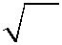
v = k W

where k is a constant for that string. W is the tension in the string which is equal to the weight of the mass hanging from the end of the string.

In (b) the weight of the mass on the end of the string is 4.0 N. The oscillator continues to vibrate the string at 120 Hz. Explain whether or not you would expect to observe a stationary wave on the string when the weight of the suspended mass is changed to 9.0 N.

...................................................................................................................................................

...................................................................................................................................................

...................................................................................................................................................

...................................................................................................................................................

...................................................................................................................................................

.............................................................................................................................................. [3]

[Total: 13]

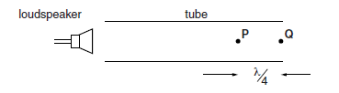
- An open tube is placed in front of the loudspeaker such that its far end is at point Q.
See Fig. 4.2.

Fig. 4.2

- Explain how and under what conditions a stationary sound wave is formed in the tube.

...................................................................................................................................
...................................................................................................................................
...................................................................................................................................
...................................................................................................................................
...................................................................................................................................
...................................................................................................................................
...................................................................................................................................
..................................................................................................................................................... [3]

- Assume that the conditions are met for a stationary wave to be set up in the tube. The distance between the points P and Q is λ/4.

Describe the motion of the air molecules

1 at point Q

............................................................................................................................................
............................................................................................................................................
............................................................................................................................................

2 at point P.

............................................................................................................................................
............................................................................................................................................
............................................................................................................................................... [3]
Total [6]

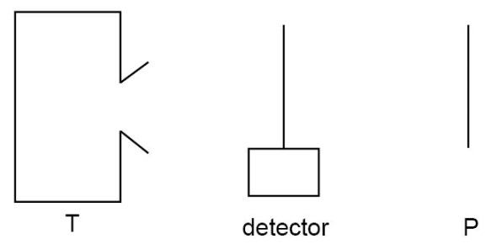
4. In the diagram, T represents a transmitter of microwaves and P represents a metal plate.

The detector is connected to a meter which gives a reading proportional to the signal strength at that point. The distance TP is much greater than the wavelength of the microwaves.
As the detector is moved from T to P what happens to the meter reading?
A | It decreases steadily
B | It reaches a maximum at P
C | It reaches a maximum midway between T and P
D | It increases and decreases rapidly
[1]

- (a) Fig. 26.1 shows the variation of displacement y with position x of a progressive transverse wave on a stretched string at a particular instant.

y
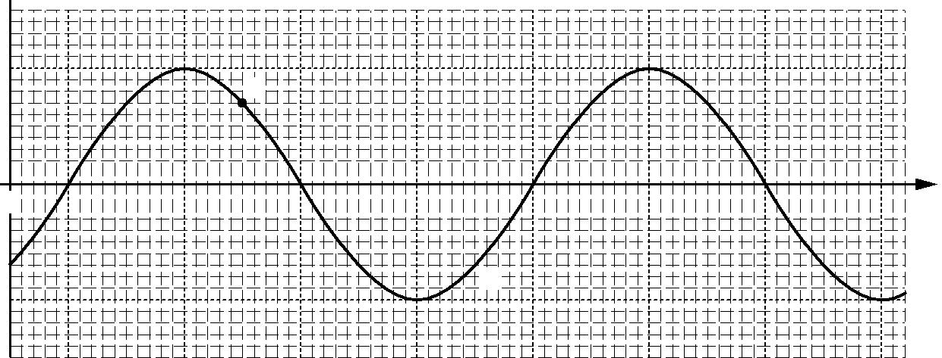

A

⁰ ₀ x

B

Fig. 26.1

The motions of particles A and B of the string is analysed over a short period of time. The distance between the positions of A and B is half a wavelength of the wave. The particles A and B have the same speed.

- State one difference between the motions of these particles.

...........................................................................................................................................

..................................................................................................................................... [1]

- The particle A oscillates with frequency 75 Hz.

The distance between the positions of A and B is (40.0 ! 2.0) cm.

Calculate the speed v of the transverse wave on the string and the absolute uncertainty in this value.

v = .................. ! .................. m s^{–1} [3]

- A stretched rubber cord has its ends fixed at points X and Y. The middle of the cord is lifted vertically and then released. A stationary wave pattern with one loop is formed by the vibrating cord, see Fig. 26.2.
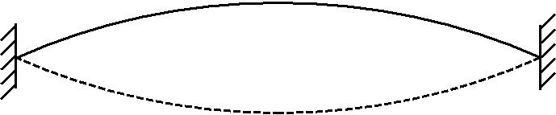

X Y

Fig. 26.2

- Explain how a stationary wave pattern is produced in this arrangement.

....................................................................................................................................

....................................................................................................................................

....................................................................................................................................

.............................................................................................................................. [2]

- The stationary wave pattern shown in Fig. 26.2 is produced in the laboratory. Describe how the wavelength of the transverse wave on the stretched cord can be determined.

....................................................................................................................................

....................................................................................................................................

.............................................................................................................................. [1]

Total [7]

