BWS A’ Level Physics
Year 12 Independent Study Booklet
DC Electricity II


Write all your answers in the spaces provided and use additional sheets where necessary.
This booklet is available for download on the website but may be updated so check you have an up to date copy.
COMPULSORY by a certain activity indicates this task must be completed ready for the time stated as your lessons that week may depend on your ability to complete certain techniques or know certain content.
Finally this booklet must be available for inspection at all times in your file.
Grade boundaries throughout for practise questions are:
- A 80%
- B 70%
- C 60%
- D 50%
- E 40%
- U <40%

Week | Topic | Prep / Consolidation | Practice |  |  | Target Areas for improvement
Week | Topic | Prep / Consolidation | Complete | Practice Mark and Grade | Corrected | Target Areas for improvement
1 | Resistivity |  |  | / 42 Grade:
2 | Power & Energy Trans. |  |  | / 32 Grade:
3 | emf, p.d and Internal Resistance |  |  | / 61 Grade:
4 | The Potential Divider |  |  | / 49 Grade:

Resistivity

Notes / Revision Preparation: | Completed
Use the A4 template PAG experimental sheet for the practical “determining the resistivity of a wire”
Independent Study Learning Preparation task:  There are high quality YouTube videos on how to complete a resistivity experiment, come prepared to the lesson, you may be asked to demonstrate the practical. | *compulsory
Isaac Physics
Read the concept page on resistivity; https://isaacphysics.org/concepts/cp_resistivity
Independent Study Practice Questions:  Complete all the questions in the spaces provided | *compulsory

1 (a) Define the resistivity of a metal wire.

...................................................................................................................................................

..............................................................................................................................................[2]

(b) In the UK the National Grid is used to transmit electric power. Each pylon supports 24 cables. See Fig. 2.1. Each cable consists of 38 strands of aluminium. See Fig. 2.2.

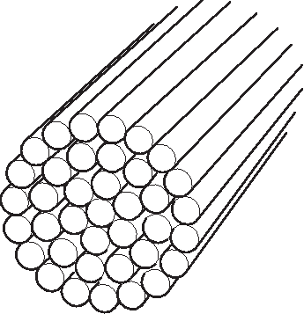
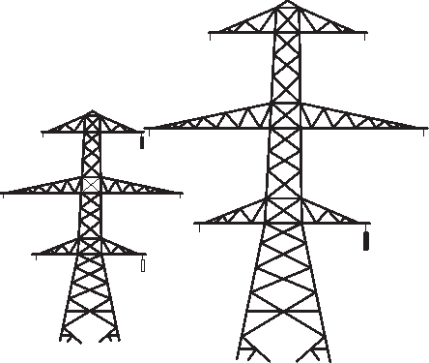

pylon

cables

pylon

cable

strand

Fig. 2.1 Fig. 2.2

(i) The resistance per km of a cable is 0.052 Ω km–1. Explain why the resistance per km of a single strand is approximately 2.0 Ω km–1.

...........................................................................................................................................

...........................................................................................................................................

......................................................................................................................................[2]

(ii) The resistivity of aluminium is 2.6 x 10–8 Ω m. Calculate the cross-sectional area A of a single strand of the cable.

A = …….…………..m2 [2]

(c) The input voltage to each cable in Fig. 2.1 is 400 kV. The cable carries a current of 440 A. Calculate

(i) the input power to one cable

input power = …………………………W [2]

(ii) the number of cables required to transmit the power from a 2000 MW power station

number of cables = …………………………[1]

- the power lost as heat per km of cable

lost power = ………………………[3]

(iv) the percentage of the input power that is available at a distance of 100 km from the power station.

percentage of power =………………………….% [2]

- This question is about the rigid copper bars which carry the very large currents generated in a power station to the transformers. Fig. 2 shows such a copper bar.

bar
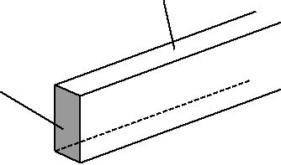
cross-sectional area A

Fig. 2

- Write down a suitable word equation to define the resistivity of a material.

...................................................................................................................................................

...................................................................................................................................................

............................................................................................................................................. [1]

- (i) The cross-sectional area A of the bar is 6.4 × 10^{–3} m². Calculate the resistance of a 1.0 m length of the bar. The resistivity of copper is 1.7 × 10^{–8} Ω m.

resistance = ...................................................... Ω [2]

(ii) The bar carries a constant current of 8000 A. Calculate the power dissipated as heat along a 1.0 m length of it.

power = ..................................................... W [3]

- The bar is 9.0 m long. Estimate the total energy in joule lost from the bar in one day.

energy = ................................................ J [2]

- (a) State the difference between the directions of conventional current and electron flow.

...................................................................................................................................................

............................................................................................................................................ [1]

(b) Circle one or more of the combinations of units which could act as a unit for current.

J s C s^{–1} V ^{–1} J C^{–1}
[2]

- Fig. 1.1 shows a current I in a thick metal wire X connected to a longer thinner wire Y of the same metal as shown in Fig. 1.1.

X
I 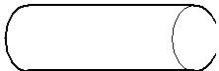 ^{Y} I

Fig. 1.1

- State why the current in Y must also be I.

...........................................................................................................................................

.................................................................................................................................... [1]

- Wire Y has half the cross-sectional area of the thicker wire X and is three times as long. The resistance R_{X} of X is 12 Ω .
1 Show that the resistance R_{Y} of Y is 72 Ω .

2 Calculate the total resistance R of both wires.

R = ..................................................... [4]

- The mean drift velocity v_{X} of electrons in X is 2.0 × 10^{–5} m s^{–1}.

Use the fact that X has twice the cross-sectional area of the thinner wire Y to calculate the mean drift velocity v_{Y} of electrons in Y. Show your working.

…………….ms⁻¹

[2]

- This question is about possible heating circuits used to demist the rear window of a car. The heater is made of 8 thin strips of a metal conductor fused onto the glass surface. Fig. 2.1 shows the 8 strips connected in parallel to the car battery of e.m.f. E and internal resistance r.

8 strips
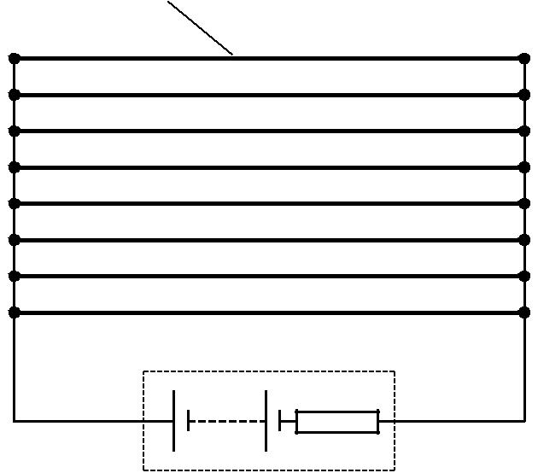

E _{r}

Fig. 2.1

(a) The potential difference across each strip is 12 V when a current of 2.0 A passes through it.

- Calculate the resistance r_{p} of one strip of the heater.

r_{p} = ..................................................... Ω [1]

- Calculate the total resistance R_{p} of the heater.

R_{p} = ...................................................... Ω [3]

- Show that the power P dissipated by the heater is about 200 W.

[2]

- Each strip is 0.90 m long, 2.4 × 10^{–4} m thick and 2.0 × 10^{–3} m wide.

Calculate the resistivity ρ of the metal of the strip. Give the unit with your answer.

ρ = ................................unit ................... [4]
Power and Energy Transfer

Notes / Revision Preparation: | Completed
Using a flash card for each show how the volt, amp, ohm and watt can be shown as a function of their base units.
Independent Study Learning Preparation task:  This task requires you to pay close attention to what devices are used in your home and when. You need to calculate the cost of the electricity delivered to your home during one day. To do so you will need to use online sources to find the power of the devices in your home and record how long they are used for. If you are struggling, then remember that one kilowatt hour is equal to one electrical ‘unit’. 1 kWh is the same as using a 1000W device for 1 hour (be careful to use 0.5 as half an hour not 0.3). Show all your calculations and use a value of 16.5p per unit + a daily standing charge of £0.23. | *compulsory
Isaac Physics
Complete any 2 Isaac Physics problems (2,3 or 4 star) on Power in circuits. Options include; Power loss in Cables, Power of a light bulb, Power limited Resistors
Independent Study Practice Questions:  Complete all the questions in the spaces provided | *compulsory

- A cell is a source of e.m.f. When the cell is connected into a circuit the potential difference measured between its terminals, called the terminal p.d., is less than its e.m.f.

  - (i) Define the term e.m.f.

...........................................................................................................................................

...........................................................................................................................................

..................................................................................................................................... [2]

- Explain why the terminal p.d. is less than the e.m.f.

...........................................................................................................................................

...........................................................................................................................................

..................................................................................................................................... [2]

- In the circuit of Fig. 3.1 the cell of e.m.f. 1.6 V and internal resistance r is delivering a current of 0.20 A to a resistor of resistance R. The voltmeter reads the terminal p.d. It is 1.2 V.

    - A

  - V
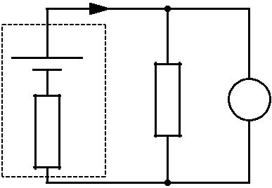
R V

r

Fig. 3.1

Calculate the values of

- the resistance R

R = ...................................................... Ω [2]

- the internal resistance r.

r = ...................................................... Ω [2]

- (i) The current in the resistor of Fig. 3.1 remains constant at 0.20 A for several hours.
Calculate:

1 the charge which passes through the resistor in 1.5 hours

charge = .................................... unit .............. [3]

2 the energy dissipated by the resistor in 1.5 hours.

energy = ...................................................... J [2]

- By mistake a householder leaves a 60 W filament lamp switched on overnight for a period of 8.0 hours.

The cost of 1.0 kilowatt-hour of electricity is 21 pence.

- Define the kilowatt-hour (kWh).

……………….............................................................................................................................

……………................................................................................................................................

………...................................................................................................................................[1]

- Calculate the cost of this electrical energy to the householder.

cost = .............................................. pence [2]

- The power of a 230 V mains filament lamp is 40 W.

  - Define power.

...................................................................................................................................................

............................................................................................................................................. [1]

- The lamp is connected to the 230 V supply. Calculate

  - the current I in the filament

I = ...................................................... A [2]

- the resistance R of the filament.

R = ..................................................... Ω [1]

- the energy dissipated in 24 hours

E = …………………………………[2]

- the cost of this energy if 1 kWh is charged at £0.15

Cost = £……….……………………..[2]

(c) The cross-sectional area of the wire of the filament is 3.0 × 10^{–8} m². The resistivity of the filament when the lamp is lit is 7.0 × 10^{–5} Ω m. Use your answer to (b)(ii) to calculate the length L of the filament wire.

L = ..................................................... m [3]

MCQ

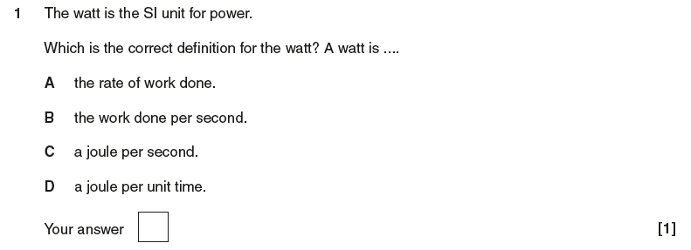

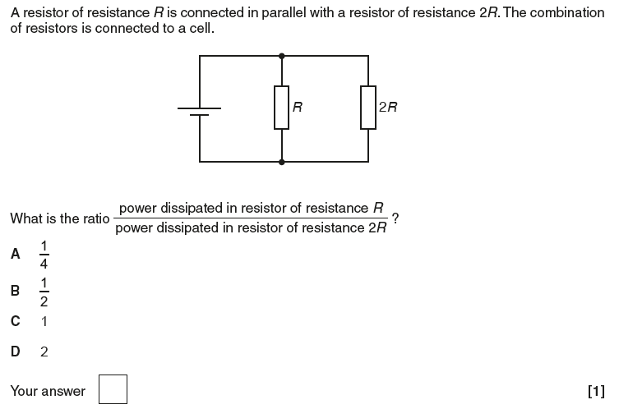

- (a) The unit of potential difference is the volt.

Use the equation W = VQ to show that the volt may be written in base units as kg m² A⁻¹ s⁻³.

[3]

Emf, p.d and Internal Resistance

Notes / Revision Preparation: | Completed
Use the A4 template PAG experimental sheet for the practical “determining the internal resistance of a cell”
Independent Study Learning Preparation task:
Complete an “Uncertainty and error in Physics” sheet for the determining the internal resistance of a cell practical. This should be done after you have completed the experiment in class.
Isaac Physics
Complete the questions on Internal resistance: https://isaacphysics.org/questions/internal_resistance_in_series
Independent Study Practice Questions:  Complete all the questions in the spaces provided | *compulsory

- (a) A 12 V car battery contains an electrolyte. The battery is connected to an electric motor M. There is a current in the motor and the battery. See Fig. 1.
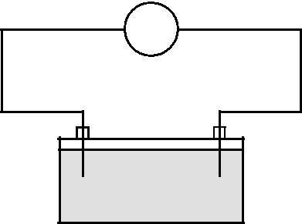

M

- –

battery
electrolyte

Fig. 1

State;

- the charge carriers in the electrolyte

....................................................................................................................... [1]

- the charge carriers moving through the electrolyte to the positive terminal of the battery

....................................................................................................................... [1]

- the charge carriers moving through the wires to the positive terminal of the battery.

....................................................................................................................... [1]

(b) When used to start the engine of the car, the electric motor draws 40 A from the battery of e.m.f. 12 V. The potential difference across the motor at this time is only 8.0 V.

- Explain why the potential difference across the motor at this time is not the same as the e.m.f. of the car battery.

............................................................................................................................

............................................................................................................................

............................................................................................................................

...................................................................................................................... [2]

(ii) Calculate the internal resistance of the battery.

……………… unit …… [3]

- It takes 1.2 s for the electric motor to start the engine. Calculate the charge Q which passes through the electric motor in this time.

Q = ..................................................... C [2]

- A cell is a source of e.m.f. When the cell is connected into a circuit the potential difference measured between its terminals, called the terminal p.d., is less than its e.m.f.

  - (i) Define the term e.m.f.

............................................................................................................................

............................................................................................................................

...................................................................................................................... [2]

- Explain why the terminal p.d. is less than the e.m.f.

............................................................................................................................

............................................................................................................................

....................................................................................................................... [2]

- In the circuit of Fig. 3.1 the cell of e.m.f. 1.6 V and internal resistance r is delivering a current of 0.20 A to a resistor of resistance R. The voltmeter reads the terminal p.d. It is 1.2 V.

    - A

  - V
R V

r

Fig. 3.1

- Calculate the value of the resistance R

R = .....................................................Ω [2]
- Calculate the value of the internal resistance r.

r = ...................................................... Ω [2]

(c) (i) The current in the resistor of Fig. 3.1 remains constant at 0.20 A for several hours. Calculate

1 the charge which passes through the resistor in 1.5 hours

charge = .................................... unit .............. [3]

2 the energy dissipated by the resistor in 1.5 hours.

energy = ............................................... J [2]

- (a) A battery of e.m.f. E and internal resistance r delivers a current I to a circuit of resistance R. Write down an equation for E in terms of r, I and R.

[1]

- A ‘flat’ car battery of internal resistance 0.06 Ω is to be charged using a battery charger having an e.m.f. of 14 V and internal resistance of 0.74 Ω, as shown in Fig. 2.1.

 |  |  |  |  |  |  |  |  |  |  | ‘flat’
 |  |  |  |  |  |  |  |  |  |  | car
 |  |  |  | 0.74 Ω | + |  |  |  | ^{0.06} ^{Ω} battery
battery |  |  | + |  | +
charger | 14 V
charger |  |  |  |  |  |  |  |  | 7.6 V
 |  |  |  | –

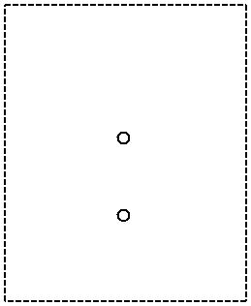

Fig. 2.1

You can see that the battery to be charged has its positive terminal connected to the positive terminal of the battery charger.

At the beginning of the charging process, the e.m.f. of the ‘flat’ car battery is 7.6 V.

- For the circuit of Fig. 2.1, determine

1 the total resistance

resistance = ............................................. Ω [1]

2 the sum of the e.m.f.s in the circuit.

e.m.f. = ............................................ V [1]
State Kirchhoff’s second law.

...................................................................................................................................................

.....................................................................................................................................................[1]

- Apply the law to this circuit to calculate the initial charging current.

current = ............................................. A [2]

(c) For the majority of the charging time of the car battery in the circuit of Fig. 2.1, the e.m.f. of the car battery is 12 V and the charging current is 2.5 A. The battery is charged at this current for 6.0 hours. Calculate, for this charging time,

- the charge that passes through the battery

charge = ..................................................... C [2]

- the energy supplied by the battery charger of e.m.f. 14 V

energy = ..................................................... J [2]

- The percentage of the energy supplied by the charger which is dissipated in the internal resistances of the battery charger and the car battery.

percentage of energy = .................................................... % [2]

- In the circuit shown the current leaving the battery is 1.5 A. The battery has an e.m.f. of 12V and an internal resistance of 1.0Ω.
6 Ω
12 Ω
Y
1 Ω

Calculate:
  - The total resistance of the circuit.

[2]

  - The resistance of resistor Y.

[2]

  - The current through the 6 Ω resistor.

[2]
- A battery of e.m.f. 12 V and internal resistance 1.5 Ω was connected to a 4.5 Ω resistor. Calculate:
- The current through the battery

[2]
- The lost p.d. and therefore the p.d. across the cell terminals

[2]
- A battery of unknown e.m.f., ε, and internal resistance, r, is connected in series with an ammeter and a resistor, R. The current was 2.0 A when R = 4.0 Ω, and 1.5 A when R = 6.0 Ω. Calculate ε and r.

ε …………………… unit ……….…..

r …………………… unit ……………. [4]

- A 6.0 V battery of unknown internal resistance was connected in series with a switch, a resistor of resistance 4.0 Ω and an ammeter. When the switch was closed, the ammeter read 1.0 A.
- Calculate the internal resistance of the battery.

[2]

- A second 4.0 Ω resistor was connected in parallel with the first resistor. Calculate the ammeter reading with this second resistor in the circuit.

[2]

- A torch bulb has a power supply of two 1.5 V cells connected in series. The potential difference across the bulb is 2.2 V, and it dissipates energy at the rate of 550 mW. Calculate:
- The current through the bulb

[2]
- The internal resistance of each cell

[2]
- The heat energy dissipated in each cell in two minutes.

[2]
The Potential Divider
Notes / Revision Preparation: | Completed
Use the A4 template PAG experimental sheet for the practical “using non-ohmic devices as sensors”
Independent Study Learning Preparation task:  Design and draw a circuit that could be used to either;  - Turn on a fan when the temperature of a room increases  - Turn on an LED when the ambient light decreases  You should not need to use any logic gates.  This task must be done before the first lesson on Potential Dividers. | *compulsory
Isaac Physics
Complete the questions on “A Diode Divider”
https://isaacphysics.org/questions/a_diode_divider
Independent Study Practice Questions:  Complete all the questions in the spaces provided | *compulsory

- A simple potential divider circuit is shown below. A 12 V d.c. supply is connected in series with a fixed 5 Ω resistor and a 3-12 Ω variable resistor. The internal resistor of the cell is 0.2 Ω.

a) The variable resistor is set to 3Ω. Calculate the current that flows in the circuit.

……………… A [3]
b) Calculate the reading on the voltmeter when:
(i) the variable resistor is set to 3Ω.

……………….V

(ii) the variable resistor is set to 12Ω.

……………….V [3]

2. Fig. 2 shows a circuit containing a battery of e.m.f. 12 V, two resistors, a light-dependent resistor (LDR), an ammeter and a switch S.The battery has negligible internal resistance.

8.0Ω

12.0V X S

12.0Ω

A
a) When the switch S is open, show that the potential difference between the points X and Y is 7.2 V.

[2]

(b) The switch S is now closed. Describe and explain the change to each of the following when the intensity of light falling on the LDR is increased:

(i) the ammeter reading
...................................................................................................................................................
...................................................................................................................................................
.............................................................................................................................................. [2]

(ii) the potential difference across XY.
...................................................................................................................................................
...................................................................................................................................................
.............................................................................................................................................. [2]

- (a) The following electrical quantities are often used when analysing circuits. Draw a straight line from each quantity on the left-hand side to its correct units on the right-hand side.

potential difference | _{C s}–1
resistance | J C^{–1}
power | V A^{–1}
current | J s^{–1}
[3]

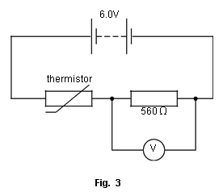
- Fig. 3 shows a battery of e.m.f. 6.0 V and negligible internal resistance connected in series with a thermistor and a 560 Ω resistor.
The voltmeter across the resistor has infinite resistance.
- The reading on the voltmeter is 2.4 V. Calculate the resistance R_{T} of the thermistor.

R_{T} = .................................................... _ [3]

- Calculate the current in the circuit.

current = ..................................................... A [1]

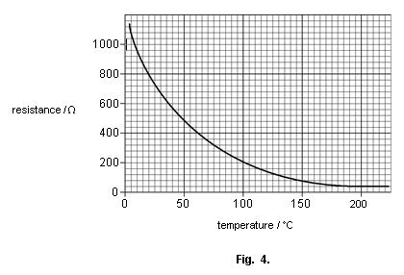
- The variation of resistance with temperature for this thermistor is shown in the graph of

- (i) Use the graph to determine the temperature of the thermistor when its resistance is 800Ω.

temperature = ................................................... °C [1]

(ii) State and explain, without calculation, how the reading of the voltmeter in Fig. 3.1 will change as the temperature of the thermistor increases to 80 °C.

..........................................................................................................................................

..........................................................................................................................................

..........................................................................................................................................

..........................................................................................................................................

.................................................................................................................................... [3]

MCQ

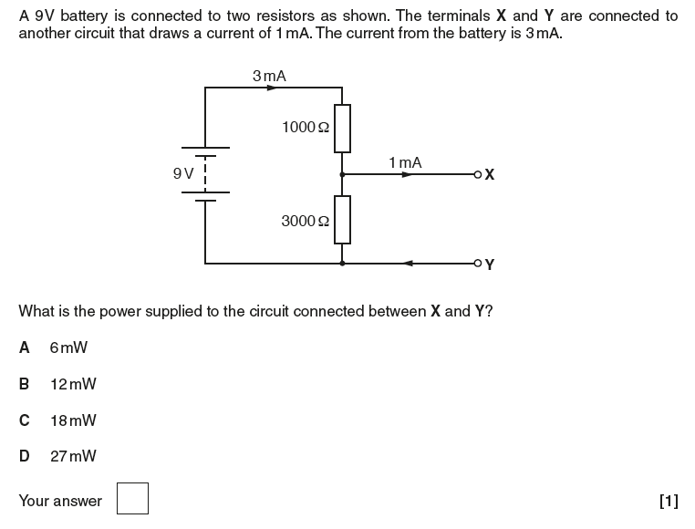

4. A series circuit is connected as shown in the diagram. What is the potential difference between A and B?

[2]
5. An additional resistor of 100 Ω is connected between the 50 Ω resistor and the cells.
What is the potential difference between A and B now?

[2]
6. The additional 100 Ω resistor is now connected in parallel with the first 100 Ω resistor. What is the potential difference between A and B now?

..........................................................................................................................................

..................................................................................................................................... [2]

- A potential divider is made from a 4 kΩ and a 6 kΩ resistor connected in series with a 20 V supply. Draw a diagram of the arrangement. What values of potential difference can be tapped off?

[3]
8. A student puts a 12 Ω variable resistor in series with a 6 V battery, expecting to get a variable potential difference.
The voltmeter is a digital multimeter. Explain why the circuit won't work. Draw a circuit which would work.

..........................................................................................................................................

..................................................................................................................................... [3]

9. B is the wiper of a 100 Ω rotary potentiometer.
What is the full range of the potential difference that can be tapped off between A and B?

Maximum p.d. …………….

Minimum p.d. …………….

Range …………………….
[3]

